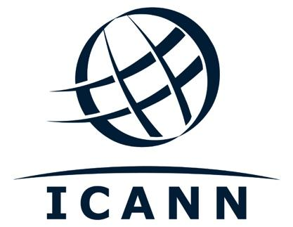

EN

AL-ALAC-ST-0222-01-00-EN
ORIGINAL: English
DATE: 17 February 2022
STATUS: Pending Ratification

AT-LARGE ADVISORY COMMITTEE
ALAC Statement on ICANN Bylaws Amendments: ccNSO-Proposed Changes to Article 10 and Annex B

Introduction

On 17 February 2022, Public Comment opened for the ICANN Bylaws Amendments: ccNSO-Proposed Changes to Article 10 and Annex B. On the same day, an At-Large workspace was created for the statement. The At-Large Operations, Finance and Budget Working Group (OFB-WG) decided it would be in the interest of end users to develop a short ALAC statement on the Public Comment. Holly Raiche, Chair of OFB-WG; Ricardo Holmquist, Vice Chair of OFB-WG; Jonathan Zuck and Olivier Crepin-LeBlond, Co-Chairs of the At-Large Consolidated Policy Working Group (CPWG), Barrack Otieno, Liaison to the ccNSO; and Maureen Hilyard, ALAC Chair, volunteered to form a small drafting team for the ALAC statement.

On 24 February 2022, Holly Raiche presented the draft ALAC statement to the OFB-WG during their bi-weekly meeting and asked the OFB-WG to provide final input on the statement. ICANN Policy staff in support of the At-Large community asked the ALAC Chair, Maureen Hilyard if she wished to have a vote or a consensus call.

On 24 February 2020, Maureen Hilyard, ALAC chair, requested that the statement be sent out to ALAC for a 48 hour consensus call.

ALAC Statement on ICANN Bylaws Amendments: ccNSO-Proposed Changes to Article 10 and Annex B

The ALAC appreciates the opportunity to respond to the ccNSO proposed changes to the Bylaws. Our understanding of the proposals is that they would address the situation where a voting imbalance is created where there is more than one ccTLD member in a country/territory, allowing those members to choose an ‘emissary’ for voting purposes. It looks to be a democratic way of resolving the issue.

As the proposed changes do not raise issues for end users, we have no further comment except to support the proposed changes.

