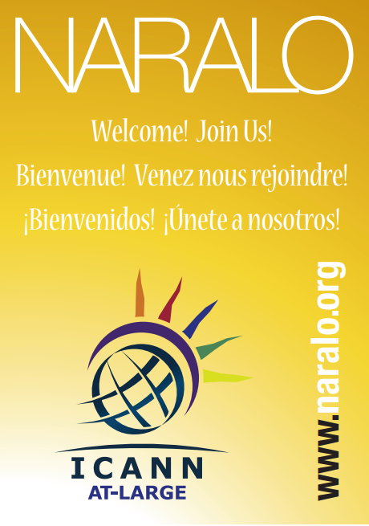

On June 12th, 2017, the North American Regional At Large Organization (NARALO) will be celebrating --its- ten year anniversary of the signing of the Memorandum of Understanding (MOU) with the Internet Corporation for Assigned Names and Numbers(ICANN) in San Juan Puerto Rico on June 12th 2007.

NARALO serves the North American region which exemplifies our slogan, MANY VOICES, ONE INTERNET. It is one of the five Regional At-Large Organizations (RALOs) that makes up the At-Large multi-stakeholder community within ICANN. The North American region encompasess end users in Canada, Puerto Rico, and United States and its other territories.

In the ten years, NARALO has grown from 10 to 29 At-Large Structures (ALS) and 19 unaffiliated members with an extensive well of knowledge of its membership on relevant Internet concerns for internet users ranging from community access to cybersecurity issues.

“Over the past ten years many of our members have been leaders in the ICANN ecosystem proving thought provoking and important policy statements, such as consumer trust and more.” Glenn McKnight, NARALO Chair

As the Internet becomes more prevalent in people’s lives we at NARALO aim to reach out and help the end users to engage with the key decision makers in making the Internet an open, trustworthy and invaluable community asset.

“I am proud of NARALO for having been able to raise the awareness among our constituencies about policies and issues discussed in ICANN that affect end-user communities and shape the global Internet.” Eduardo Diaz, President of ISOC Puerto Rico, one of the original signatories on the MOU and the incoming NARALO Chair.

To learn more NARALO please visit www.naralo.org

Contact
Glenn McKnight.NARALO Chair
naralo-leadership@atlarge-lists.icann.org
-30-

