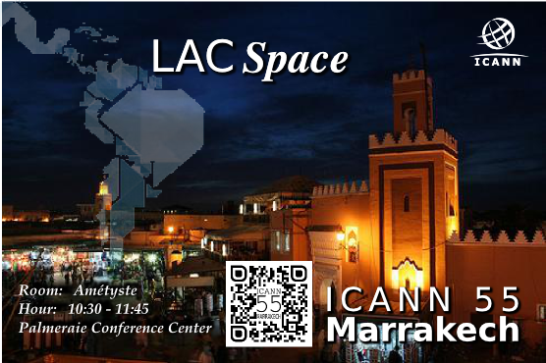

10:30 – 10:35 | Introduction | Rodrigo de la Parra VP Stakeholder Engagement-Latin America Caribbean ICANN  Vanda Scartezini - Polo Consultores
10:35 – 10:50 | African DNS Initiatives | Bob Ochieng - Stakeholder Engagement Manager - Africa
10:50– 11:05 | The new gTLD program Auction Funds. | Lauren Allison - Development And Public Responsibility Program Manager ICANN  Or  Marika Konings - Senior Director, Policy Development Support And Team Leader For The GNSO
11:05 – 11:20 | Comments on the new gTLD program Auction Funds. | Anthony Harris – CABACE  Dev Dev Anand Teelucksingh - LACRALO
11:20 -11:35 | LAC DNS Marketplace Study and LAC DNS Entrepreneur Center | Daniel Fink - Manager Stakeholder Engagement Brazil ICANN
11:35 -11:45 | Q&A

