2015 Nominating Committee Report Card #3
December 2014 – January 2015
Date: 3 February 2015

- Application period underway

To date, the 2015 Nominating Committee has received and fulfilled 74 requests for forms to be used by candidates in applying for the nine ICANN leadership positions open in 2015. Many intend to apply for multiple positions. Of the total number, 41 have indicated they will apply for the Board as their first choice, 11 for the GNSO Council, and 14 for the ALAC and 8 for the ccNSO Council.

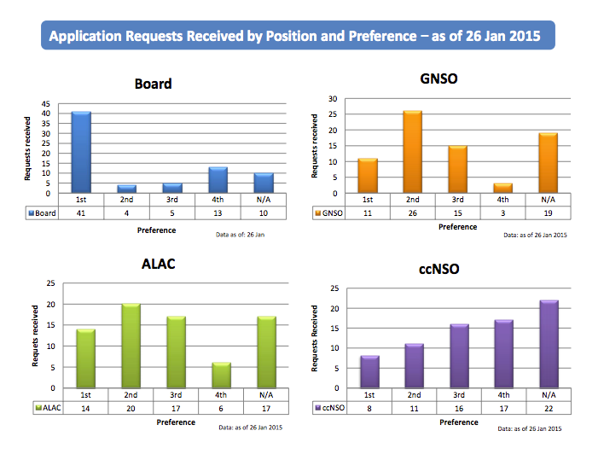

The application period was opened on 8 December, 2014. It will run until 15 March, 2015.

The open positions are:

- Three members of the ICANN Board of Directors
- Three At-Large Advisory Committee (ALAC) representatives (one each from the Africa, Asia/Australia/Pacific Islands and Latin America/Caribbean Islands regions)
- Two members of the Council of the Generic Names Supporting Organization (GNSO)
- One member of the Council of the Country Code Names Supporting Organization (ccNSO)

According to ICANN Bylaws, the number of Directors from countries of one of ICANN’s Geographic Regions cannot exceed five.The Board has to include at least one Director who is from a country in each ICANN Geographic Region. The graph below shows the present composition (voting Directors only) of the Board in regional and gender terms.

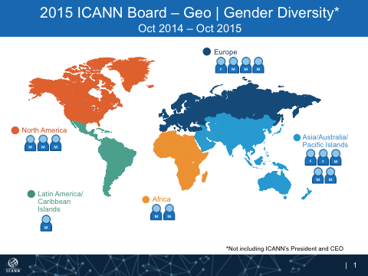

2) Outreach

NomCom members have been engaged in outreach activities within their own networks and at various events around the world where they have participated:

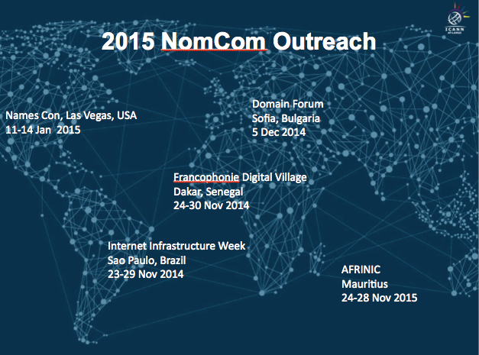

- The 4th Brazilian Internet Infrastructure Week in Sao Paulo, Brazil, 23-29 November, 2014
- The 23rd meeting of AFRINIC (The Internet Numbers Registry for Africa), 24-28 November, 2014
- Village de la Francophonie (in connection with the XV Summit of the Francophonie), Dakar, Senegal, 24-30 November, 2014
- Bulgarian Domain Forum 2014, Sofia, Bulgaria, 5 December,2014
- NamesCon (The largest conference dedicated to the domain name industry), Las Vegas, Nevada, USA, 11-14 January, 2015

Outreach is planned for the 39th meeting of APNIC (Asia-Pacific Network Information Centre) and the 24th meeting of APRICOT (Asia-Pacific Regional Conference on Operational Technologies), to be held in Fukuoka, Japan, 24 February – 6 March, 2015, as well as at the 33rd meeting of the Messaging, Malware and Mobile Anti-Abuse Working Group in San Francisco, California, USA, 16-19 February 2015, and at IETF 92 in Dallas, Texas, USA, 22-27 March, 2015.

A major opportunity for outreach by all NomCom members will be the 52nd meeting of ICANN in Singapore, 8 – 12 February, 2015

3)Transparency

The 2015 NomCom continues to adhere to the policy of balance between confidentiality and transparency established by 2013 and 2014 NomComs:
Maximal transparency within the limits set by confidentiality requirements
regarding the personal data of individual candidates. “Process is open, data is
secret”. Aggregate information about candidates, including regional and gender distribution, will be published in a timely fashion.

Monthly Report Cards will be issued during the entire NomCom cycle.

More community participation to NomCom open meetings in Singapore and Buenos Aires will be sought by targeted invitations to all stakeholder groups.

Social media will be used with the help of ICANN Communications team.

4) Next steps

2015 NomCom will hold in Singapore a public meeting session on Wednesday, 11 February, 11:00-12:15 in the Indiana room, 4th level of the Raffles City Conference Center. This is an opportunity for community members to give their views to the NomCom and to find about its work. At the internal sessions, NomCom members will be trained in interview techniques and familiarized with Wiki based tools for candidate assessment.

After the applications deadline, the NomCom will start assessing the candidates and taking straw polls with an accelerating schedule of teleconferences in April-June. A number of Board candidates will be interviewed and assessed by OdgersBerndtson (Frankfurt). Shortlisted Board candidates will be invited to ICANN 53 (Buenos Aires, June 21-25, 2015) for face-to-face interviews. NomCom will hold its final selection meeting immediately after ICANN 53.

Selections are announced in August/September, and selectees will take up their positions after ICANN’s Annual General Meeting (Dublin, October 18-22 2015)

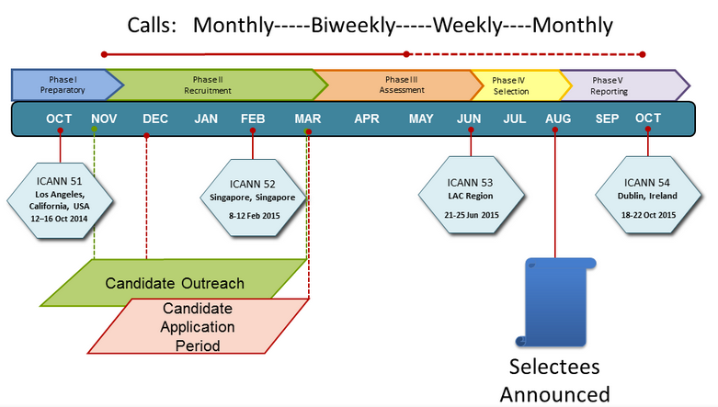

Appendix: 2015 NomCom essentials

Committee Leadership:
Chair (chosen by the Board): Stéphane Van Gelder Associate Chair (chosen by Chair): Cheryl Langdon-Orr Chair Elect (chosen by the Board to prepare for the Chairmanship of the 2016 NomCom): Ron Andruff
Committee:
Voting members: 5 ALAC; 1 ccNSO; 1 ASO; 1 IAB; 7 GNSO (RrSG, RySG, NCUC, ISPCP, IPC, CBUC [1 small / 1 large business rep])
Non-voting members: 1 SSAC, 1 RSSAC, 1 GAC1 ICANN Staff support: Joette Youkhanna, Jia-Juh Kimoto
ICANN Staff support: Joette Youkhanna, Jia-Juh Kimoto

Sub-committees:

- Conflict of interest (Chair: Cheryl Langdon-Orr)
- Outreach and recruitment (Chair: Ron Andruff)
- Transparency (Chair: Yrjö Länsipuro)
- Wiki SOI revisions (Chair: Ron Andruff)
- Alternates for unexpected vacancies (Chair: Cheryl Langdon-Orr)

Meetings (since the start of 2015 NomCom):

Kick-off face-to-face meeting in Los Angeles, 17-18 October, 2014

In attendance: Chair; Chair Elect; Associate Chair; 5 ALAC; 1 NCUC; 1 ISPCP; 1 ccNSO; 1 ASO; 0 IPC; 1 RrSG; 1 RySG; 1 SSAC; 1 RSSAC, 2 BC; 1 IAB for IETF. Apologies received from members unable to attend.

Teleconference 4 November, 2014

In attendance: Chair; Chair Elect; Associate Chair; 5 ALAC, 1 NCUC;1 ISPCP; 1 ccNSO; 1 ASO; 1 IPC; 0 RrSG; 1 RySG; 1 SSAC; 1 RSSAC, 2 BC; 0 IAB for IETF. Apologies received from members unable to attend.

Teleconference 2 December, 2014

In attendance: Chair; Chair Elect; Associate Chair; 5 ALAC, 1 NCUC;1 ISPCP; 1 ccNSO; 1 ASO; 1 IPC; 1 RrSG; 1 RySG; 1 SSAC; 0 RSSAC, 2 BC; 1 IAB for IETF. Apologies received from members unable to attend.

Teleconference 22 December, 2014

In attendance: Chair, Associate Chair, 5 ALAC, 1 NCUC, 1 ISPCP, 1ccNSO, 1 ASO, 0 IPC, 1 RrSG, 0 SSAC, 0 RSSAC, 2 BC, 1 IAB for IETF. Apologies received from members unable to attend.

Teleconference 28 January, 2015

In attendance: Chair, Chair Elect, Associate Chair, 4 ALAC, 1 NCUC, 0 ISPCP, 0 ccNSO, 1 IPC, 0 RrSG, 0 RySG, 0 SSAC, 0 RSSAC, 2 BC, 1 IAB for IETF. Apologies received from members unable to attend.

Wiki/SOI Subcommittee conference calls:
5 November 2014
11 November 2014
24 November 2014

Transparency Subcommittee conference calls:
18 November 2014
15 December 2015

Outreach Subcommittee conference calls:
6 November 2014
20 November 2014

In order to maintain the confidentiality of the application process, it is conducted within a restricted ICANN wiki space. To start the process, the candidate first has to file an application form request https://forms.icann.org/en/groups/nomcom/apply
https://www.icann.org/resources/pages/2015-2014-11-14-en

