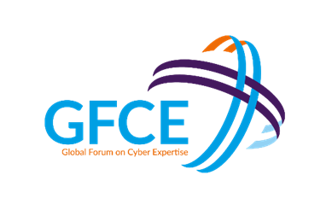
GFCE Triple-I Day @LACIGF2019
Monday August 5, 2019
ATIX hotel, La Paz, Bolivia

Capacity Building towards a more trusted
Internet experience in the region

DRAFT AGENDA
TIME | TOPIC(s) | PEOPLE
09:00 | WELCOME & OPENING | Opening by Lito Ibarra, intro by Maarten Botterman –GFCE Triple-I
09:20  ~90 minutes | BLOCK I - Better Use of Today’s Open Internet Standards  Presenting and discussion on the use and usefulness of Open Internet Standards such as DNSSEC/TLS/DANE, RPKI/ROA, DMARC/DKIM/SPF and IPv6 | Introductions by Daniel Fink, (ICANN), and Lia Solis (LACNOG, ISOC Bolivia), specific contributions by Gerardo Rada (LACNIC) on RPKI and participation by all.
 | Coffee/tea break
11:25 | BLOCK II - Inspiration from Good Practice Actions  Presentation and discussion of a number of global good practices and good practices from the region that are deemed potentially relevant for capacity building and to inspire action in the region
II.a  ~60 minutes | Anti-abuse work  The Internet is not good or bad in itself: it is how it is used that matters. Early detection of abuse (whether purposefully or by mistake) will help to contain damage by being able to alert users and actively take measures against the abuse. Globally, and in the region, working groups have been set up to actively detect and fight abuse by raising awareness on the key issues at hand, and take action to fight this abuse, together (#LACAAWG; #M3AAWG; #DAAR; etc) | Lucimara Desidera (Chair, LAC AAWG; Member, M3AAWG) will provide a background on work currently going on in the region and world-wide, and will explain how other stakeholders can benefit from this, and contribute to this. Daniel Fink (ICANN, DAAR) will talk about ICANN’s activities in fighting abuse in the DNS industry, and Israel Rosas (ISOC, MANRS) will talk about the importance of MANRS; Actors in the region are invited to share their experiences and engage in the discussion.
12:30 | Lunch | Complementary for all participants
13:30  II.b  ~30 minutes | CERT collaboration  CSIRTs play a major role in fighting abuse. For CSIRT collaboration, trust is key. What are today key CERT concerns and activities, how can stakeholders benefit, and what stakeholders do to help? | Lucimera Desidera (Member of CERT.br/NIC.br and FIRST), will explore this together with other CERT Members. All participants are invited to join the discussion and explore opportunities for joint action.
14:00  II.d  ~ 60 minutes | Secure IoT deployment: global insights in the way forward  This presentation will cover some guidelines and recommendations from practice that Internet users, governments and IoT manufacturers can follow to secure the Internet of Things, based on recent work by ISOC and the IGF Dynamic Coalition on IoT. | Sebastian Bellagamba – Internet Society; Maarten Botterman – IGF DC IoT  Participants are invited to share their concerns and insights with regards to implementation of IoT as a “safe enabler” of benefit.
II.c  ~30 minutes | Other exemplary practice  - National DNSSEC introductions;  - Internet.NL  - … | Speakers to be announced  Participants are invited to discuss the proposed way forward, and what role for MANRS in the region.
15:30 | Coffee/tea
16:00  III  ~90 minutes | Block III: Planning for a More Trusted Internet: Marketplace for Action  During this block, conclusions will be drawn and possible actions will be developed aimed at increasing trust in the use of Internet and email in the region. This will be a facilitated brainstorming. | Failitated by Maarten Botterman, and Lito Ibarra  Participants are invited to suggest actions and ways forward, and are asked to commit to actions of their specific interest.
17:30  ~5 minutes | Conclusions and closure  The main insights gained and actions agreed will be summarized, including a poll on the interest to repeat this workshop in 2020. | Maarten Botterman and Lito Ibarra

This workshop is initiated by the Global Forum for Cyber Expertise (https://www.thegfce.com) and is supported by LACIGF (https://lacigf.org/), LACTLD (https://www.lactld.org/), LACNIC (https://www.lacnic.net/), LACAAWG, nic.br/cgi.br (https://cgi.br/), ICANN (http://www.icann.org), Internet Society (http://www.informationsociety.org) and its Bolivian Chapter, and the Dutch Ministry of Economic Affairs and Climate.
The workshop will be held in English and Spanish, and where necessary, contributions/questions will be facilitated by consecutive translation in the room, as to ensure all participants can express themselves in the language they are most comfortable in.
For more information about GFCE Triple-I, including results of earlier events, please go to the GFCE Triple-I pages. If you are interested in improving the trusted Internet experience in your region … if you are eager to meet with like-minded people from other sectors and learn together … join us in La Paz on 5 August 2019, or contact the GFCE Triple-I facilitator Maarten Botterman to set up an event in your region.
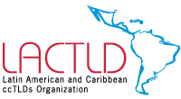
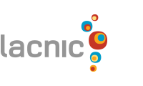
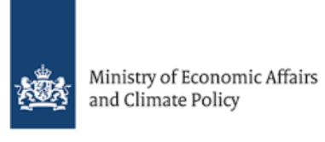
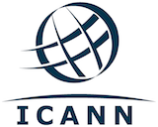
For registration for the 2019 GFCE Triple-I event @LACIGF2019, on 5 August 2019 in the ATIX hotel, La Paz, Bolivia, please register here.

