2016 Nominating Committee Report Card #1
October 2015
Date: 30 October 2015

1) Leaders to be selected by 2016 NomCom

In 2016, the Nominating Committee (2016 NomCom) makes selections for the following seven leadership positions for ICANN:

- Three members of the ICANN Board of Directors
- Two At-Large Advisory Committee (ALAC) members (one each from Europe and North America)
- One member of the Council of the Generic Names Supporting Organization (GNSO)
- One member of the Council of the Country Code Names Supporting Organization (ccNSO)

2) 2016 NomCom starts work

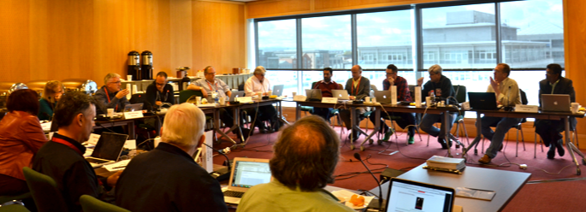

The Nominating Committee mandated with the selection of ICANN leaders in 2016 started its work at a two-day kick-off meeting, held in Dublin 23-24 October, 2015, after ICANN 54.

The 2016 NomCom is comprised of a non-voting Leadership Team (3), voting members (15) and non-voting liaisons (2) with staff support (2).

Leadership Team:

Stéphane Van Gelder, Chair
Hans-Petter Holen, Chair Elect
Wolfgang Kleinwächter, Associate Chair

Voting members:

Dave Kissoondoyal (ALAC-AF)
Amir Qayyum (ALAC-AP)
Yrjö Länsipuro (ALAC-EUR)
Eduardo Diaz (ALAC-NA)
Sylvia Herlein Leite (ALAC-LAC)
Steve Coates (GNSO-CBUC-Large)
Zahid Jamil (GNSO-CBUC-Small)
Ken Stubbs (GNSO-Registries)
Thomas Barrett (GNSO-Registrars)
Osvaldo Novoa (GNSO-ISPCP)
Ellen Shankman (GNSO-IPC)
Bill Drake (GNSO-NCUC)
Jörg Schweiger (ccNSO)
Hartmut Glaser (ASO)
Tom Wicinski (IAB for IETF)

Non-voting members:

Alejandro Acosta (RSSAC)
Mark Seiden (SSAC).

Staff:

Joette Youkhanna
Jia-Juh Kimoto.

3) Kick-off meeting reviews procedures

At its face-to-face meeting in Dublin, the Nominating Committee met with John Jeffrey, the General Counsel and Secretary of ICANN, who explained the duties of Board Directors, and Steve Crocker, the Chair of ICANN Board, who briefed the NomCom on how the Board works and what skill sets its members require.

The 2016 NomCom reviewed the procedures of its predecessors and decided on necessary changes and clarifications. It was decided that:

- non-voting SSAC and RSSAC liaisons can participate in all deliberations of the NomCom, including straw polls, with the exception of the final vote on the slate of selectees;
- quorum is nine (9) voting members – as long as this number is reached at any meeting (face-to-face or teleconference), any absentee NomCom member accepts any majority decision during said meeting.
- while making its final selections, the NomCom also prepares for the eventuality of unexpected vacancies. Alternates will be selected, but the individuals in question will not be informed of this unless it becomes necessary to call upon them.
- outside assistance for recruitment and evaluation of candidates will be used

The NomCom also confirmed that it is going to follow the practice of 2015 NomCom in having a “whistleblower e-mail” for signaling any possible misconduct, and assenting to 360 degree reviews of both the Leadership Team and members, with results published on NomCom’s website.

4) Sub-committees

The 2015 NomCom decided to set up the following Sub-Committees:

1) Recommendations Sub-Committee (Chair: Hans-Petter Holen, members: Zahid Jamil, Tim Wicinski, Eduardo Diaz) to review the recommendations from the 2015 NomCom and ensure the 2016 NomCom makes best efforts to enact them.

2) Conflict of Interest Sub-Committee (Chair: Wolfgang Kleinwächter, members: Dave Kissoondoyal, Steve Coates, Zahid Jamil, Mark Seiden, Ken Stubbs) to handle any declared conflicts of interest concerning a member of the NomCom.

3) Outreach Sub-Committee (Chair: Wolfgang Kleinwächter, members Tom Wicinski, Sylvia Herlein Leite, Amir Qayyum, Ken Stubbs, Yrjö Länsipuro, Dave Kissoondoyal, Steve Coates, Osvaldo Novoa, Tim Wicinski, Alejandro Acosta) to create and manage a calendar of outreach events at which NomCom attendance might be useful.

4) Application Software Sub-Committee (Chair: Mark Seiden, members Amir Qayyum, Tim Wicinski, Zahid Jamil) to suggest improvements to the software currently used in the application process

5) SOI Revision Sub-Committee (Chair: Steve Coates, members Zahid Jamil, Thomas Barrett) to suggest improvements to the content design and language of the Statement of Interest forms.

6) Reference Communications Sub-Committee (Chair: Bill Drake, members: Dave Kissoondoyal, Jörg Schweiger, Eduardo Diaz, Sylvia Herlein Leite) to suggest improvements to the reference form

7) Transparency Sub-Committee (Chair: Yrjö Länsipuro, members: Dave Kissoondoyal, Eduardo Diaz, Osvaldo Novoa, Jörg Schweiger) to ensure the NomCom operates as transparently as possible. This includes drafting the report cards.

8) Recruitment/Evaluation vendor Sub-Committee (Chair Zahid Jamil: members: Yrjö Länsipuro, Thomas Barrett, Osvaldo Novoa) to prepare for possible alternative recruitment partners to be asked to work with future NomComs, starting with the 2017 committee.

9) Travel logistics Sub-Committee (Chair: Hartmut Glaser, members: Zahid Jamil, Mark Seiden, Sylvia Herlein Leite, Amir Qayyum) to suggest solutions to problems related to travel to face-to-face meetings (visas, ICANN travel rules etc)

5) Phases of NomCom work and timeline

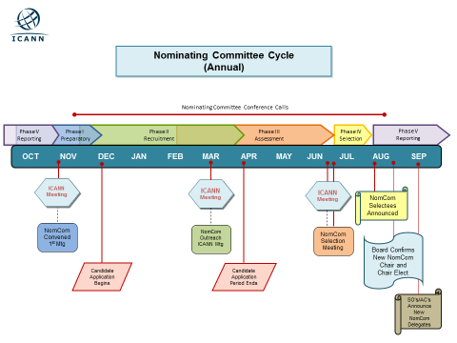

The graph shows a generic NomCom cycle. Exact times for the start and close of the application period will be announced shortly

At the kick-off meeting, the NomCom reviewed the phases and approximate timelines of the work ahead. After a brief preparatory phase, the work begins with outreach and recruitment, in which every member is supposed to engage using his/her networks and relevant events he/she attends. A calendar of such events will be set up and updated. After the application period closes, (some time after ICANN55) the assessment phase begins with members reading the applications and references and then proceeding to a series of teleconference discussions and straw polls (also using special secure wiki pages) to winnow down the candidate pools for each position. At this stage, a number of Board candidates may be interviewed by outside experts retained for the purpose.

Meanwhile, NomCom members, working in teams of 2 - 3 to insure a mix of experienced and new members, are acquainting themselves in great detail with the applications and supporting material presented by 2-3 candidates (for various positions) assigned to each team. This phase, also known as “deep diving”, may also include telephone interviews with candidates for ALAC, GNSO and ccNSO leadership positions. As far as Board members are concerned, after the outside expert’s assessments and a new round of NomCom deliberations, shortlisted candidates (seven or less) are invited to face-to-face interviews with the NomCom at ICANN56. Immediately after that meeting, NomCom makes it final selections. The last phase is reporting, which includes announcing the selection, preparing the final report and making recommendations to the 2017 NomCom.

According to ICANN Bylaws, Art. VII, Sec. 7, “The Nominating Committee shall adopt such operating procedures as it deems necessary, which shall be published on the Website.”

