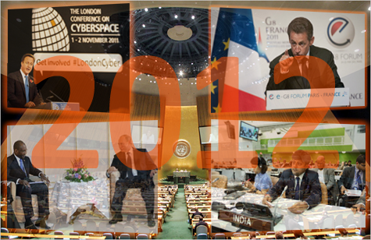

Internet Governance Outlook 2012:

Cold War or Constructive Dialogue?
Wolfgang Kleinwächter
The Internet and the way it is governed may well become a big political controversy in 2012. Two billion people are now online. The network supports annual business transactions of several trillion dollars. And it has evolved into a strategic resource in national and international power struggles. High stakes indeed!
To make it simple, there are two options: either we continue with a free and open Internet that has historically enabled innovation, economic growth, social development and free communication. Or we take a U-turn towards a regulated, restricted, censored and fragmented Internet where national policies of governments and commercial interests of corporations reduce or strangulate individual rights and freedoms.
The risk of a collateral damage
There are numerous forces and stakeholders across the globe that have all manner of good or bad arguments for change. While nothing stands still and while the Internet needs a constant enhancement and improvement, the risk is high that the proposed introduction of political or economic safeguards to repair some of the Internet’s weaknesses will lead to unintended side-effects with the potential of massive collateral damage.
It does not help if the intentions are good. Governments argue they need more control to protect national security. Law enforcement argues they need more surveillance to fight cybercrime. Right owners argue they need more regulation to stop piracy. Brand owners argue they need more restrictions to protect their trademarks.
Each argument has its value. But the understandable wish to get rid of the “bad things” risks throwing out the baby with the bathwater. An open and free Internet would become closed and censored. Balancing the conflicting interests among governments, industries and civil society requires high diplomatic skills by widely different partners. There is no straightforward path.
The problem is all the more complicated because it is not possible to slice the Internet into different parts. There is one world and one Internet and changes under A will impact B, C and D and vice versa. The Internet Governance ecosystem is a multi-layered mechanism that requires the different parties to work together. And there are many different parties, governmental and non-governmental, that manage, regulate, organize, control, oversee and develop parts of the Internet. Each party needs the others and all the parties together constitute the net of networks that we call the Internet. There is no single authority responsible for the Internet as a whole.
For those used to classic hierarchical power structures, this situation is confusing. They would prefer to have one telephone number and one switch for the global Internet. But would the necessary re-centralization, re-nationalization and re-regulation for that to happen represent a real improvement?
Various parties have different ideas what improvement of Internet Governance means: for one group it is the establishment of a new centralized inter-governmental Internet organization. For others, it is the strengthening of the decentralized multi-stakeholder governance model. It is, in other words, hierarchies versus networks.
“If it isn’t broken, don’t fix it”, has been the argument for many years of Vint Cerf, one of the fathers of the Internet. He is right. A neutral analysis tells us that the Internet as a whole is not broken. It has weaknesses and risks, and it gives the “bad guys” the same opportunities as it gives to the “good guys”, unfortunately. But the Internet works and was able to accommodate unbelievable growth from two million to two billion users within 20 years without any significant problems.
There is no doubt that the global community has to strengthen its efforts to fight criminals, pedophiles, vandals, terrorists and hate-preachers online and offline. But the Internet is not the source of the world´s evil. Like a knife in the hand of a murderer, the Internet is no more than an instrument. Try to deal with crime by focusing on knives makes no sense.
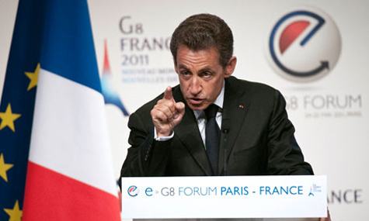
French PM Sarkozy pushes for a 'civilized' Internet
Likewise, efforts to “heal the Internet” could do more harm than good. The wrong medicine can kill. And 2012 will see a growing armada of “doctors” selling their wares in dozens of intergovernmental and non-governmental institutions offering their ointments and unctions to make the Internet “healthy” (as China wants), “civilized” (as the French president argued) or “hygienic” (as the US President prescribed).

The theater of war: United Nations
In 2012, the main theater for the global Internet Governance controversy will be the United Nations, spread through a number of different meetings running across the whole year.
It starts with two meetings of the IGF Improvement Working Group of the UN Commission for Science and Technology Development (UNCSTD) in January and February in Geneva and will end with the 67th UN General Assembly (UNGA) in fall 2012 in New York.
The IGF Improvement Working Group was established at the end of 2010. It ended in March 2011 with nothing, unable to reach a result. In July, its mandate was renewed and a new chair, Peter Major, is now trying to bring the different interests of governments, private sector, technical community and civil society under one umbrella until the next CSTD meeting (May 2012 in Geneva). The CSTD will then report, via the ECOSOC, back to the 67th UNGA and its 2nd Committee which starts negotiations in October 2012.
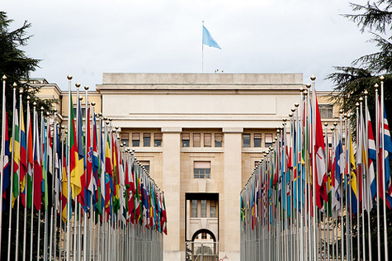
Most of the debates will be held at the UN in Geneva
Even the Multistakeholder Advisory Group (MAG), which prepares the annual IGFs, remained without a mandate since the sixth IGF. In the meantime, the seventh Internet Governance Forum (IGF), scheduled for November 2012 in Baku, has to be prepared. The IGF team lost last year both its chairman (Nitin Desai) and its Executive Secretary (Markus Kummer) and so far, no new appointments have been made. Even the Multistakeholder Advisory Group (MAG), which prepares the annual IGFs, remained without a mandate since the sixth IGF in Nairobi. There is a speculation in the community, whether this delay is by intention or just the result of a slow UN bureaucracy. A number of governments do not like the IGF and would prefer to kill it, to make it unworkable (by giving it a mandate to negotiation treaties) or to water it down (by combining it with the annual WSIS Forum in Geneva, organized by ITU). Only in December 2011, the UN asked for new nominations for a MAG and it remains to be seen, what the planned IGF consultations mid-February 2012 in Geneva will produce.
The other Internet conflict which keeps the CSTD and the 2nd UNGA Committee busy is the so-called “process on enhanced cooperation”, a leftover from the World Summit on the Information Society (WSIS) of 2005. Enhanced cooperation is a diplomatic buzzword for governmental control over the critical Internet resources. In 2011, the IBSA-countries (India, Brazil, South Africa) proposed the establishment of a new intergovernmental body, a “United Nations Committee for Internet-Related Policies” (CIRP). The mandate of the proposed CIRP would include “to coordinate and oversee the bodies responsible for technical and operational functioning of the Internet” (i.e. the IETF, ICANN, W3C, RIRs, IEEE and others), to “facilitate negotiations on treaties, conventions and agreements on Internet related policies” and to “undertake arbitration and dispute resolution”. Each point has its own explosive potential.
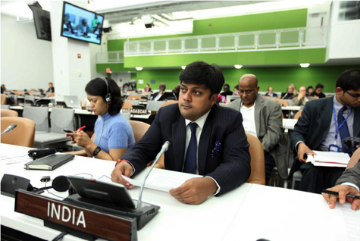
Indian MP Dushyant Singh introduces the CIRP proposal
In turbulent negotiations in November 2011 the project was watered down but it will not disappear in 2012. The UNGA adopted a resolution which invites now the chair of the CSTD “to convene a one day open, inclusive and interactive meeting” to identify “a shared understanding about enhanced cooperation on public policy issues, pertaining to the Internet.” The meeting will take place in conjunction with the 15th CTSD meeting (Geneva in May 2012). It would be a big surprise if this consultations end in harmony.
A Treaty for Cybersecurity?
But it is not only the 2nd UNGA committee where a time-bomb is ticking. For years the 1st UNGA Committee, responsible for international security and disarmament, has been discussing a Russian proposal on cybersecurity. In 2011, the Shanghai Group (Russia, China, Uzbekistan, and Tajikistan) enriched the discussion by introducing a draft for an intergovernmental “Code of Conduct” which would define “norms and rules guiding the behavior of states in the information space”.
Russia successfully introduced a new paragraph in the annual resolution which now requests that the UN Secretary General “continue to study existing and potential threats in the sphere of information security and possible cooperative measures to address them, including norms, rules or principles of responsible behavior of states and confidence building measures with regard to the information space.”
Behind the vague diplomatic language is another Russian proposal for a new legally binding “Convention on International Information Security”. The draft convention (September 22, 2011) has 23 articles with more than 100 paragraphs and is based on the idea that in the global borderless Internet non-interference into domestic affairs and national sovereignty gets priority. The draft is full of vague language related to “illegal content”, “destructive information action” and “information wars”. And it gives all rights to manage the Internet into the hands of governments, as it is proposed in Article 5, para. 5: “Each State Party has the right to make sovereign norms and govern its information space according to its national laws.”
The proposal is not yet an official UN document, but it will come back in 2012 and another UN body, called the “Group of Governmental Experts on Developments in the Field of Information and Telecommunications in the context of International Security” (GGE), chaired by Andrey Krutskych from the Russian Foreign Ministry, will discuss elements of it.
The issue of Information Security could also become a controversial subject during the next G8 meeting under the US presidency in Chicago in mid-May 2012. Last year, under the French G8 presidency, the leaders of the eight countries extensively discussed for the first time the Internet and agreed in Deauville (May 2011) on a number of principles, including strengthening cybersecurity, free flow of information and the multi-stakeholder approach. It remains to be seen, how the Russian idea of “information security” can be combined with the International Cybersecurity Strategy US President Obama published in May 2011. It could become a heated debate in windy Chicago if the new Russian president is then Vladimir Putin.
ITU is waiting
Putin, in his capacity as Russian prime minister, visited the ITU in Geneva in June 2011. When he met the ITU Secretary General Hamadoun Toure he said: “We are thankful to you for the ideas that you have proposed for discussion. One of them is establishing international control over the Internet using the monitoring and supervisory capabilities of the ITU. If we are going to talk about the democratization of international relations, I think a critical sphere is information exchange and global control over such exchange. This is certainly a priority on the international agenda.”
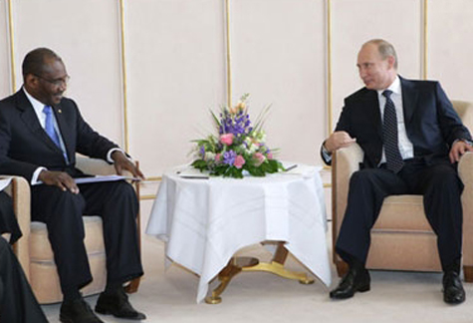
ITU SG Hamadoun Toure talks with Russian PM Vladimir Putin
How far this will go will be seen in December 2012 when the ITU “World Conference on International Communications” (WCIT) starts in Dubai. WCIT, a purely intergovernmental conference, has to re-negotiate the “International Telecommunications Regulations” (ITRs), a legal binding treaty from 1988. Not only Russia but a large number of other countries want to use this opportunity to extend the ITRs and to include legally binding provisions for nearly all aspects related to the governance of the Internet. Just recently Toure said that the world should learn from the financial crisis, caused by inadequate regulation and supervision. He warns that the Internet could collapse and he offers the help of the ITU to “avoid a catastrophe” by proposing the elaboration of a detailed regulatory framework and the introduction of strong oversight.
The ITU would love to become the organizational home for international cybersecurity policy-making but playing on the fear that a “catastrophe” is on the horizon if ITU does not get an enhanced mandate is not wise policy. Meanwhile, Toure appears to have done almost nothing to implement Resolution 102 of his own Plenipotentiary Conference in Guadalajara in November 2010 which asked the ITU to “explore ways and means for greater collaboration and coordination between ITU and relevant organizations”, in particular ICANN, the RIRs, IETF, ISOC and W3C. Is he just waiting for the Dubai conference to change the rules of the game?
If the IBSA countries fail to make progress in the UN with its CIRP proposals in New York in November 2012, they could join Russia and China in Dubai in December 2012. And all five big Internet powers could make this a subject of discussion for the forthcoming G20 meeting in Mexico City in June 2012.
London Agenda
Adding to all this activity, it will be interesting to see how the so-called London Agenda initiated by UK Foreign Secretary William Hague in November 2011 can develop alternatives to strengthen cybersecurity by taking into account human rights and individual freedom and including non-governmental stakeholders into the policy development process.
It is still unclear what additional value the “London Agenda” will bring to the global Internet Governance dialogue. To multiply discussions without a clear strategy behind it is not only confusing but could become counter-productive, in particular if the first stop of this new train is Budapest. Hungary’s prime minister Orban faces significant criticism from human rights groups for his restrictive media and Internet policy.
Also unclear is how the Budapest conference will be linked to EURODIG, the European IGF, which is scheduled for June 2012 in Stockholm. Carl Bildt, the Swedish Foreign Minister and former chair of ICANN's At Large Membership Study Committee (ALSC), was a speaker at the London conference and will co-host EURODIG. Bildt was also a speaker at the Internet Governance conference in The Hague in December 2011 where US Secretary of State Hillary Clinton argued for a “truly global coalition to preserve on open Internet.” Clinton welcomed ideas to introduce sanctions and export controls for companies which export dual use technologies of suppression to repressive regimes.
But it is not only the dual use for surveillance technology which creates more and more problems, it is also the dual use of policies and legislation and a double standard in its implementation which adds to the confusion and has the potential to enhance misunderstanding and feed a cold cyberwar.
When after the London riots the British prime minister David Cameron was thinking about control of Facebook and Twitter, he was celebrated in Beijing as being “on the right track”. When the US congress discussed the Stop Online Piracy Act (SOPA,) the “Moscow Herald” titled an article “US joins China in Internet Censorship” and gave the impression that Russia is the only remaining country in the world where freedom of the Internet has a home. German Internet surveillance technology is send to Iran, Libya and Syria and the German parliament discusses data retention while the German Foreign Minister celebrates the Arab Internet Spring and condemns Internet censorship abroad.
It makes certainly a difference if Internet restrictions are implemented in a country where a critical public and a constitutional court can stop governments if they violate basic individual rights and freedoms, or in a country where such policies remain unchallenged because the critical public will be jailed and no independent judiciary is in existence. However it is not easy to draw a fine line that separates the justified from the unjustified. Who has the final authority to define who is the good and who the bad guy in cyberspace? It is like in the 20th century’s East-West cold war where the Freedom Fighters of the West were seen as the aggressors by the East and the Peace Fighters of the East were seen as the terrorists by the West.
The discussion about double standards will not stop with SOPA and surveillance technology. It will continue in 2012 in other UN Specialized Agencies as WIPO and the WTO. In WIPO “intermediary liability” is an issue. Recently, Russia proposed in the “WIPO Advisory Committee on Enforcement” to introduce new legal mechanism to fight against cross border cases of infringement, especially in the field of P2P technologies and called for a study “how governments can regulate the relationship between stakeholders disseminating information over the Internet.” This is another ticking bomb for the next WIPO Plenary.

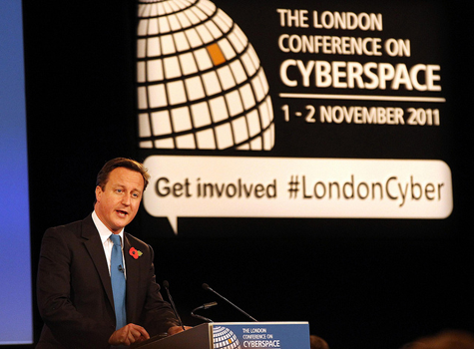
British PM Cameron: Faced criticism over social media control suggestion
Furthermore, a group of WTO members have singled out some issues based on the TRIPS agreement and related to the protection of intellectual property in cyberspace for a special Anti-Counterfeiting Trade Agreement (ACTA). This is seen by many Internet stakeholders as an effort to cure the disease by killing the patient. The French HADOPI law is one example how good intentions can turn bad by undermining fundamental freedoms in a democratic society. Economic arguments to introduce control are no less dangerous than political arguments to introduce censorship. As Hillary Clinton said in The Hague: “There isn’t an economic Internet, a social Internet and a political Internet. There is just the Internet and we are here to protect what makes it great.” Good words. Now adequate policies have to be delivered.
So where is the good news?
We’ve reviewed some of the threats and fears surrounding Internet governance in 2012, but where are the options for a constructive dialogue?
In 2011, two regional inter-governmental bodies created frameworks that may provide guidance for the future of the Internet. The OECD with its 34 member states worked on a set of principles for Internet Policy Making. And The Council of Europe, with 47 member states, adopted a Declaration on Internet Governance Principles.
Both documents offer a source of inspiration for how to move toward something like a “Universal Declaration on Principles to Govern the Internet”, similar to the Universal Declaration of Human Rights, developed in 1948. Both the OECD and Council of Europe documents cover more or less the same issues, propose rather similar principles but have also some interesting differences.
Both are in favor of the universality and integrity of a secure and stable Internet, they both support the multi-stakeholder governance model and the empowerment of Internet users, and they want to keep the existing architecture of the Internet (the end-to-end principle) with its open networks and decentralized management. However, while the OECD sees those principles more through the lens of the Internet economy, the Council of Europe approaches it from a human rights point of view. As a result, OECD failed to get the support from its civil society advisory body CISAC while the Council of Europe didn’t face any opposition from non-governmental stakeholder groups.

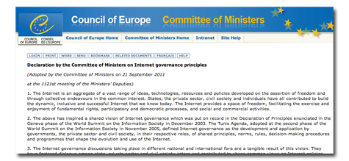
The Council of Europe's Internet governance principles
But now it’s time for implementation. The OECD has translated its Communique from July 2011 into a “OECD Council Recommendation on Principles for Internet Policy Making” (December 13, 2011) and has invited their member states to “consult, coordinate and cooperate at national and international levels through multi-stakeholder processes towards the effective implementation of the recommendation.” The Ministerial Committee of the Council of Europe adopted the “Declaration on Inter Governance Principles” in September 2011 and is considering now how to enhance its coverage, both geographically and institutionally, in a phase II.
When the OECD and Council of Europe discussed their documents with non-European partners at the sixth IGF in Nairobi (under the title “A Constitutional Moment in the History of the Internet”) it became clear, that this can’t be the last step. There is now a Council of Europe proposal to move from an “Intergovernmental Declaration of Principles” toward a “Multi-stakeholder Framework of Commitments” (FoC) – something that would be the logical next move into the still unknown territory of a 21st century diplomacy.
Increasingly it is understood that arrangements among governments without the inclusion of private companies (like Google and Facebook), technical bodies (like ICANN and IETF) or civil society organizations (like EFF and APC) have a limited meaning. The year 2012 could become the starting point for political innovation where a new mechanism is built in which governmental and non-governmental stakeholders negotiate as equals, taking into account their respective roles, and working together to keep the Internet open, free, safe, robust, resilient, reliable, stable, efficient, flexible, competitive and dynamic.
One proposal discussed in Nairobi was to investigate whether something like an “Internet Constitution” in the form of a non-binding set of universal principles accepted by all stakeholders would be a useful instrument. Such a universal document could embrace all proposals for Internet Governance principles proposed in 2011 by nearly twenty organizations, including the IGF Dynamic Coalition on Internet Rights and Principles (IRP). Like the Universal Declaration of Human Rights it would be a legally non-binding formal commitment by governments, corporations, civil society and the technical community. It would be something like a new multi-stakeholder “Netiquette” for the Internet.
Where this could be done? The IGF is a multi-stakeholder body which has no negotiation capacity (and should not have one); the United Nations has a negotiations capacity but it is not a multi-stakeholder body. What is obviously needed is something in between.

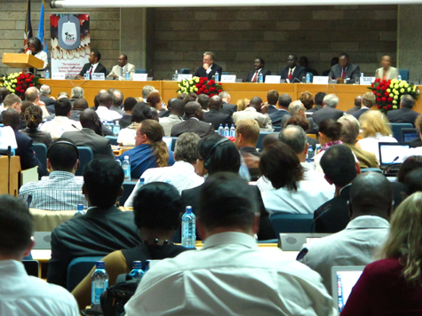
The IGF in Nairobi some discussion of different Internet principles text.
One idea has grown up of a new, mixed group with a (very) limited mandate to draft such a universal text. The Working Group on Internet Governance (WGIG) in 2004/2005 served as a demonstration that such an approach can work. WGIG worked with members from all stakeholder groups and had a clear but limited mandate. In the end, it drafted recommendations that pleased both the heads of states of 150+governments as well as the non-governmental parts of the global Internet community. Key parts of the WGIG report like the Internet Governance definition, made its way directly, word by word, into the “Tunis Agenda”.
How could one proceed? Here is a proposal for something like a WGIG version 2.0. During the next IGF in Baku (November 2012) a “Multi-stakeholder Expert Group on Internet Governance” (MEGIG) could be established with 48 members, twelve experts form each stakeholder group from developed and developing countries, nominated by the stakeholders themselves via the MAG. Its meetings could be linked to the annual open IGF consultations in Geneva, but work independently. Technical support could come from the IGF Secretariat. The budget would come from voluntary contributions. A first draft of the envisaged document could be discussed during the 8th IGF in 2013, a second draft during the 9th IGF in 2014. And the final version could be adopted by acclamation during 10th IGF in 2015.
Stress Test for ICANN
ICANN is another playing field in Internet Governance Policies in 2012. Controversies appear around the new gTLD program and the renewed IANA contract. A first moment of truth came on 12 January this year, when ICANN opened the window for new gTLD applications. Up until the last minute, large and powerful groupings of mainly US-based global corporations and member states of ICANN´s Governmental Advisory Committee (GAC) tried to block the program. Two Congressional Hearings in the US, an editorial in the Washington Post and letters from the European Commission are a good stress-test for how ICANN handles serious concerns by individual members of the various stakeholder groups continuing with its transparent bottom-up multi-stakeholder policy development and implementation process. It is a risky moment. But 2012 is a year where ICANN has to deliver.
If the US government had followed the pressure applied by the Association of National Advertisers (ANA), big US corporations, the FTC chairman and the advice by the “Washington Post” and would have stopped the new gTLD program, the Chinese and the Russian governments, who do not much like ICANN and the GAC, would have been handed easy arguments for how ICANN continues to be an instrument of the US government and therefore why alternative models for the management of critical Internet resources (CIR) under the UN are needed.
Larry Strickling, director of NTIA and Assistant Secretary in the US Department of Commerce made clear what is at stake in a speech in December 2011: “The multi-stakeholder process does not guarantee that everyone will be satisfied with the outcome. But it is critical to preserving the model of Internet Governance that has been so successful to date that all parties respect and work through the process and accept the outcome once a decisions is reached.” And he added that an intervention by the US government would “provide ammunition to other countries who attempt to justify their unilateral actions to deny their citizens the free flow on the Internet. This we will not do. There is too much at stake here”. We will see how those wise words will guide the US Department of Commerce in the negotiations for the new IANA contract, which terminates end of March 2012.
What else?
There are, of course, many more bodies that deal with Internet issues. UNESCO has postponed its controversial “Code of Ethics for the Information Society” for further consideration in 2012. The UN Human Rights Council is dealing with Internet rights and freedoms based on the report by Frank La Rue and a resolution, introduced by the Swedish foreign minister Carl Bildt, which is aimed to stop filtering and blocking of content in the internet and nullifying the liability of Internet intermediaries. The 19th session of the Council takes place early March 2012 in Geneva.
Two months later the WSIS Forum will have Internet Governance on its agenda (Geneva, May 2012). The European Commission has its “Digital Agenda 2020” and Commissioner Nelly Kroes has announced that the EU will propose in 2012 an “Internet Compact”. The EU is also working on a document for the “Internet of Things” (IoT). It remains to be seen how this will fit into the mainstream of the global Internet governance dialogue.
Last year, for the first time, a group of non-governmental technical organizations (ICANN, ISOC, IETF and the RIRs) formed a new platform – they called it “I*” (I-star) - to bundle the power of the technical community and to prepare it for the forthcoming Internet Governance battles. And ISOC will celebrate its 20th anniversary in April 2012 in Geneva.
Next to EURODIG there will be numerous regional and national IGFs around the globe. The Organization for Security and Co-operation in Europe (OSCE) had two Internet conferences in Tblissi and Duschanbe in 2011 and will continue to make Internet Governance a priority in their plans for 2012. NATO is enhancing its policies for cybersecurity and cyberwar in 2012. And a large number of civil society organizations are preparing conferences, actions and research projects.
Roughly calculated there will be more than 50 “very important meetings“ (VIMs) on Internet Governance issues in 2012. Good time for travel agents :-)
Stumbling forward
The good thing with the Internet is that nobody really knows what exactly will happen next. Twenty years ago there were no search engines; 15 years ago there was no YouTube; 10 years ago there were no social networks. And five years ago we had only little experiences with cloud computing. Who knows what we will see in 2017 or 2022?
When former US President Bill Clinton addressed the ICANN meeting in San Francisco in March 2011, he described Internet Governance as a process of ”stumbling forward”. Stumbling is not bad, he said, as long as it goes forward.

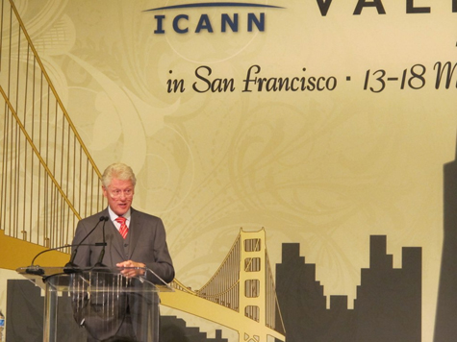
Bill Clinton speaks at the ICANN meeting in San Francisco. Credit: Domain-Pack
The Internet community could further stumble forward in 2012 if it finds answers to the three questions below:
- How do we re-balance conflicting values such as security, property, freedom and privacy in Internet applications and services within and among different political systems that possess different cultures, traditions and historical experiences?
- How do we develop a new relationship between governmental and non-governmental institutions which is not based on hierarchy but on mutual collaboration among equals, and which accounts for the specific roles and responsibilities of each individual stakeholder?
- How do we combine the traditional centralized, closed and top-down approach taken by governments and inter-governmental bodies that deal with public policy issues with the open, transparent and bottom-up mechanisms, typical for non-governmental Internet organizations dealing with the management and the further development of critical Internet resources and infrastructures?
The answers to these three questions will vary depending on who you talk to and where there based, whether governments, private corporations, civil society organizations or the technical community in the West, the Arab world, in China, Russia, Brazil, India or Africa. There is no consensus in the world.
There is no real alternative to building bridges and constructive dialogueHowever we all are using the same Internet. There is no real alternative to building bridges and constructive dialogue. This year, 2012, will not see a solution of the problem. But 2012 could be the start of a process that enhances individual freedom, economic growth and social development. A Chinese saying is that the longest march starts with the first step. The long march on the Internet road started years ago. In 2012 we have to make the next small step. And this step should go forward and not backwards.

Wolfgang Kleinwächter is a professor for Internet Policy and Regulation at the University of Aarhus. While he is a member of several committees mentioned in this article he expresses here his personal opinion.

