BOOK LAUNCH INVITATION- WEBINAR
Roundtable Overcoming the Jurisdictional Challenge of the Internet?
Friday 26. March 2021 15:00-16:45
Zoom Link https://qmul-ac-uk.zoom.us/webinar/register/WN_x5h-MZSPRyGqUt2NwQAHiA
To celebrate the publication of:
Julia Hörnle “Internet Jurisdiction: Law & Practice” Oxford University Press 2021
https://global.oup.com/academic/product/internet-jurisdiction-law-and-practice-9780198806929?cc=gb&lang=en&
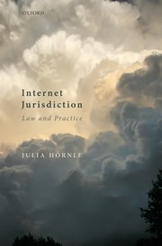
15:00- 15:10 Welcome
Prof Julia Hörnle, Queen Mary University of London
15:10-16:10 Roundtable Presentations
Chair: Prof Daithi Mac Sithigh, Queen’s University Belfast
Prof Cedric Ryngaert, University of Utrecht
“Internet regulation & extraterritorial jurisdiction: does one follow from the other?”
“Dr Lorna Gillies, Edinburgh Napier University
“Mosaic jurisdiction in privacy, defamation and IP disputes- a differential approach & future outlook for a Brussels Ter Regulation?”
Prof Alisdair Gillespie, Lancaster University
“Jurisdiction and cybercrime offences: links to territory and substantial measure”
16:15-16:45 Discussion

