PRESS RELEASE

CREDO GLOBAL LAUNCHES IN BERLIN

Estrel Centre, Berlin, Germany, 27th November 2019 at 4:30pm.

Acting Secretary General of the Commonwealth Telecommunications Organisation (CTO) Fuatai Gisa Purcell gave the keynote address as she officially launched Credo Global. Purcell in her remarks said that “we live in a time of unprecedented crises politically, socially, economically and the world today faces global challenges that demand global solutions. The nature of the global challenges demand global solutions and enhanced collaboration where people are at the center of the development”.

Purcell further said that “Now more than ever, we need nations, communities, organisations and individuals to engage in thoughtful processes and to share experiences to enable countries and communities to leapfrog so that together we can achieve the Sustainable Development Goals
(SDGs)”.

Honourable Charles Mok, Member of Hong Kong Parliament gave opening remarks and congratulated Credo Global on its launch and said “Think Tanks allow for building a bridge between civil society, private sector and governments.”

“Credo Global is about building lasting relationships and putting people first above activities and initiatives” said President of New Sight International and member of Core Leadership Council of Congress WBN, Paul Humberstone.

Purcell said that Credo Global is a Think Tank, which is an offshoot of UK based Charity called New Sight International that has been in existence for over 30 years as it was formally registered in May, 1989, the same year that the Berlin Wall fell.

New Sight International as a Charity has been engaged in global community development initiatives for over 30 years spanning across Africa, South America and this year has set up a global Think Tank.

Credo Global’s Managing Director is Rebecca Crosbie and Director Operations is Salanieta Tamanikaiwaimaro. Credo Global’s Advisory Council includes Paul Humberstone (UK), Bevil Wooding (Trinidad and Tobago), Sokol Haxhiu (Albania), Tobias Mahler (Norway), Aslam Hayat (Pakistan).

The Launch was also attended by a cross section of people from nations around the world, which included Hon. Ir. Ayobangira Safari Nshuti MP and National Deputy of the Democratic Republic of Congo, Chief Executive Officers of Development Agencies and Organisations, Private Sector, Governments and Civil Society from Europe, Asia, Australasia, Oceania, Caribbean and the Pacific.

The Pacific was represented at the launch in Berlin by Seluvaia Kauvaka (Ministry of Meterology, Energy, Information, Disaster Management, Environment, Climate Change, Communications and CERT), Jeff G Liu (Vanuatu CERT), Jackson Miake (Vanuatu IGF), Dalsie Banialala (Pacific Regulatory Advisor), Amelia Kamanalagi Muriel of Pasifika Nexus who is based in France and others from Fiji. Also present at the Launch were Pakistan Telecommunication Authority’s Assistant Director Waqas Hassan; Coordinator of Nigeria Internet Governance Forum, Mary Uduma; June Parris of Barbados who currently serves on the Multistakeholder Advisory Group (MAG).

Africa Open Data and Internet Research Foundation’s President and Chief Executive Officer Wisdom Dongkor declared that this is a new day for global development with respect to collaboration on pressing digital issues confronting underserving communities.

ENDS

Contact

Ms Naomi Kitcher
Email: naomi.kitcher@credoglobal.org

Phone: +44 7972116784

Website: www.credoglobal.org
Facebook: Credo Global
Instagram: globalcredo
Linkedin: Credo Global Think Tank
Twitter: @GlobalCredo

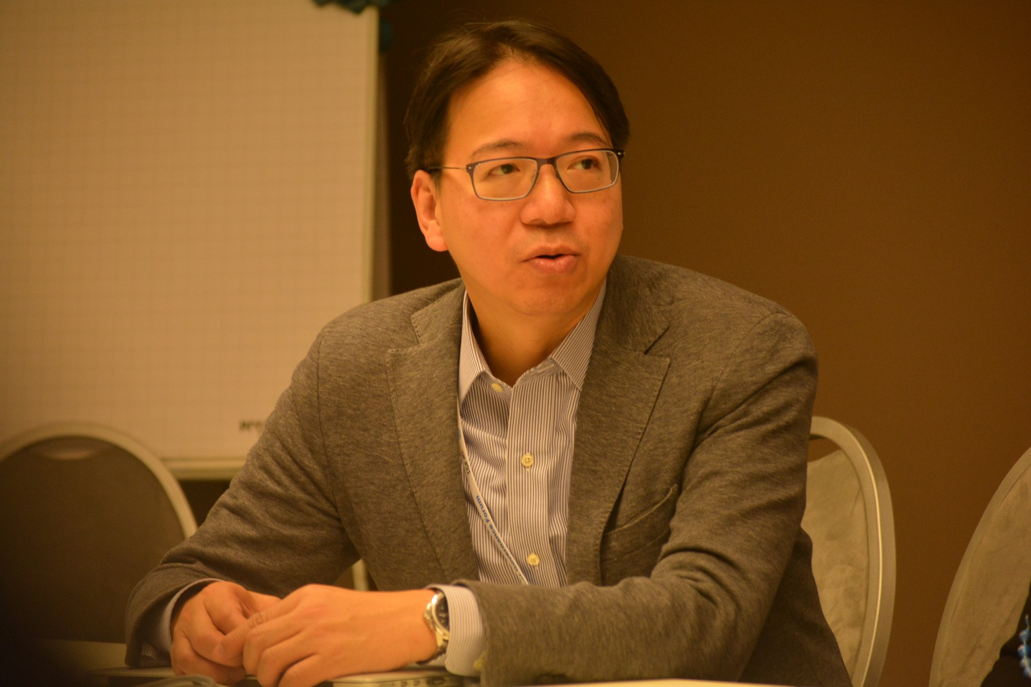
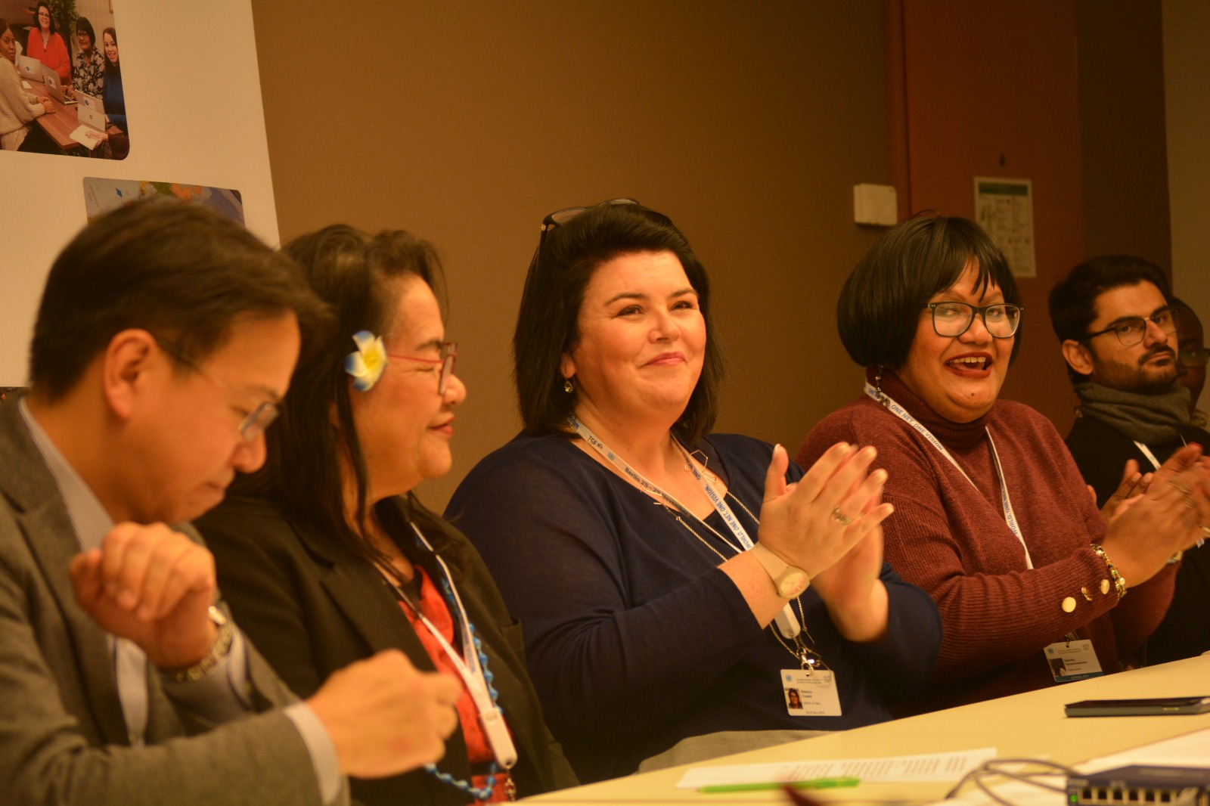

L-R Hon. Charles Mok MP Hong Kong, China, Hon. Gisa Fuatai Purcell, Commonwealth Telecommunications Organisation Acting Secretary . General, Rebecca Crosbie, Salanieta Tamanikaiwaimaro, Waqas Hassan
Hon. Charles Mok MP Hong Kong, China

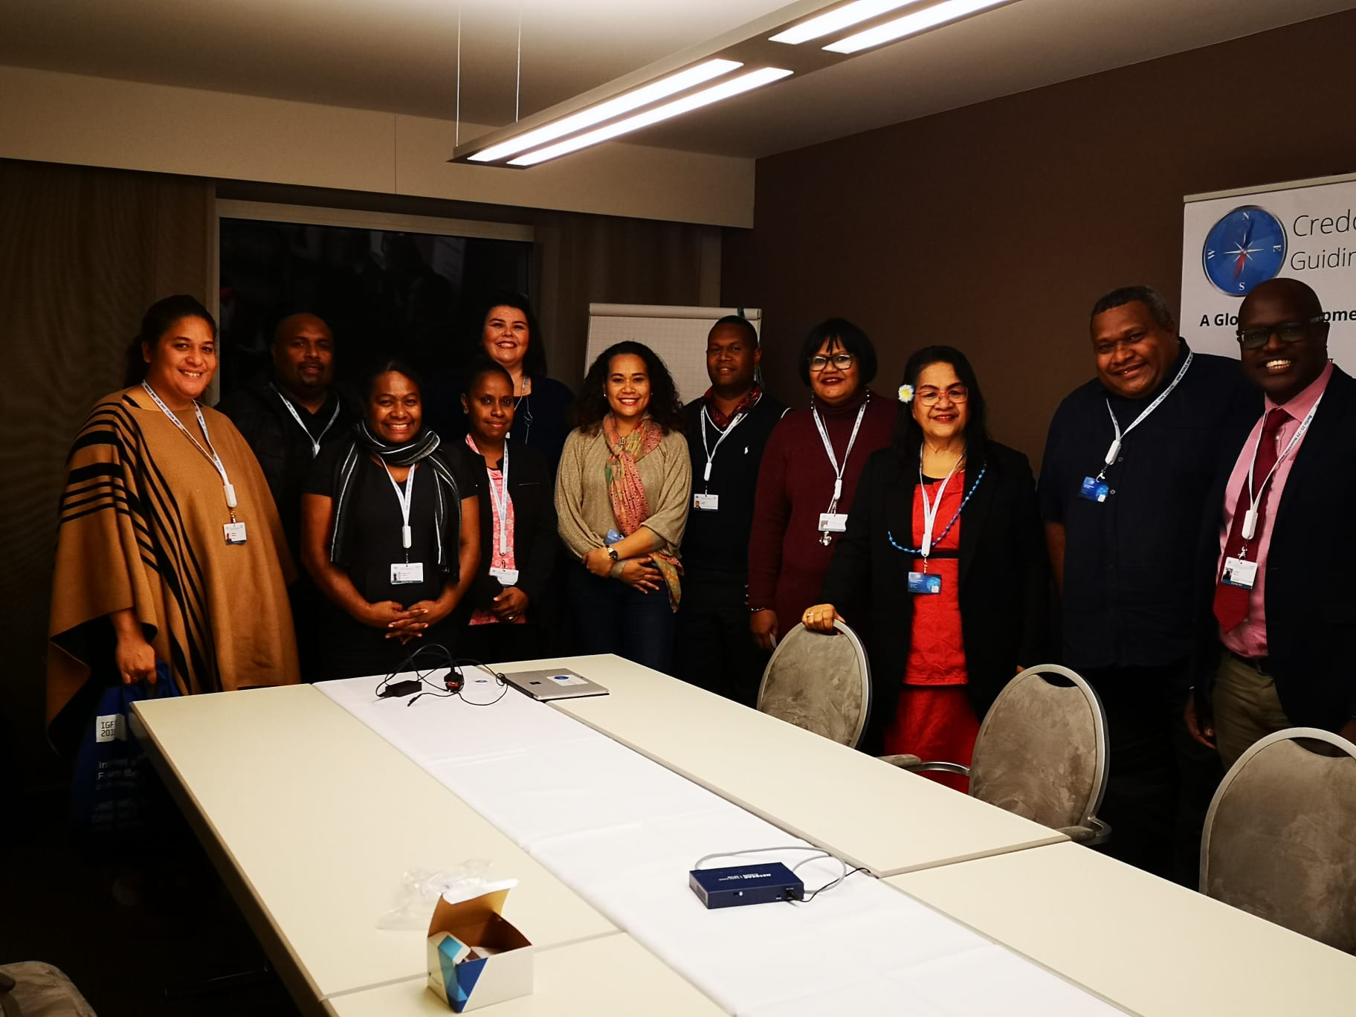

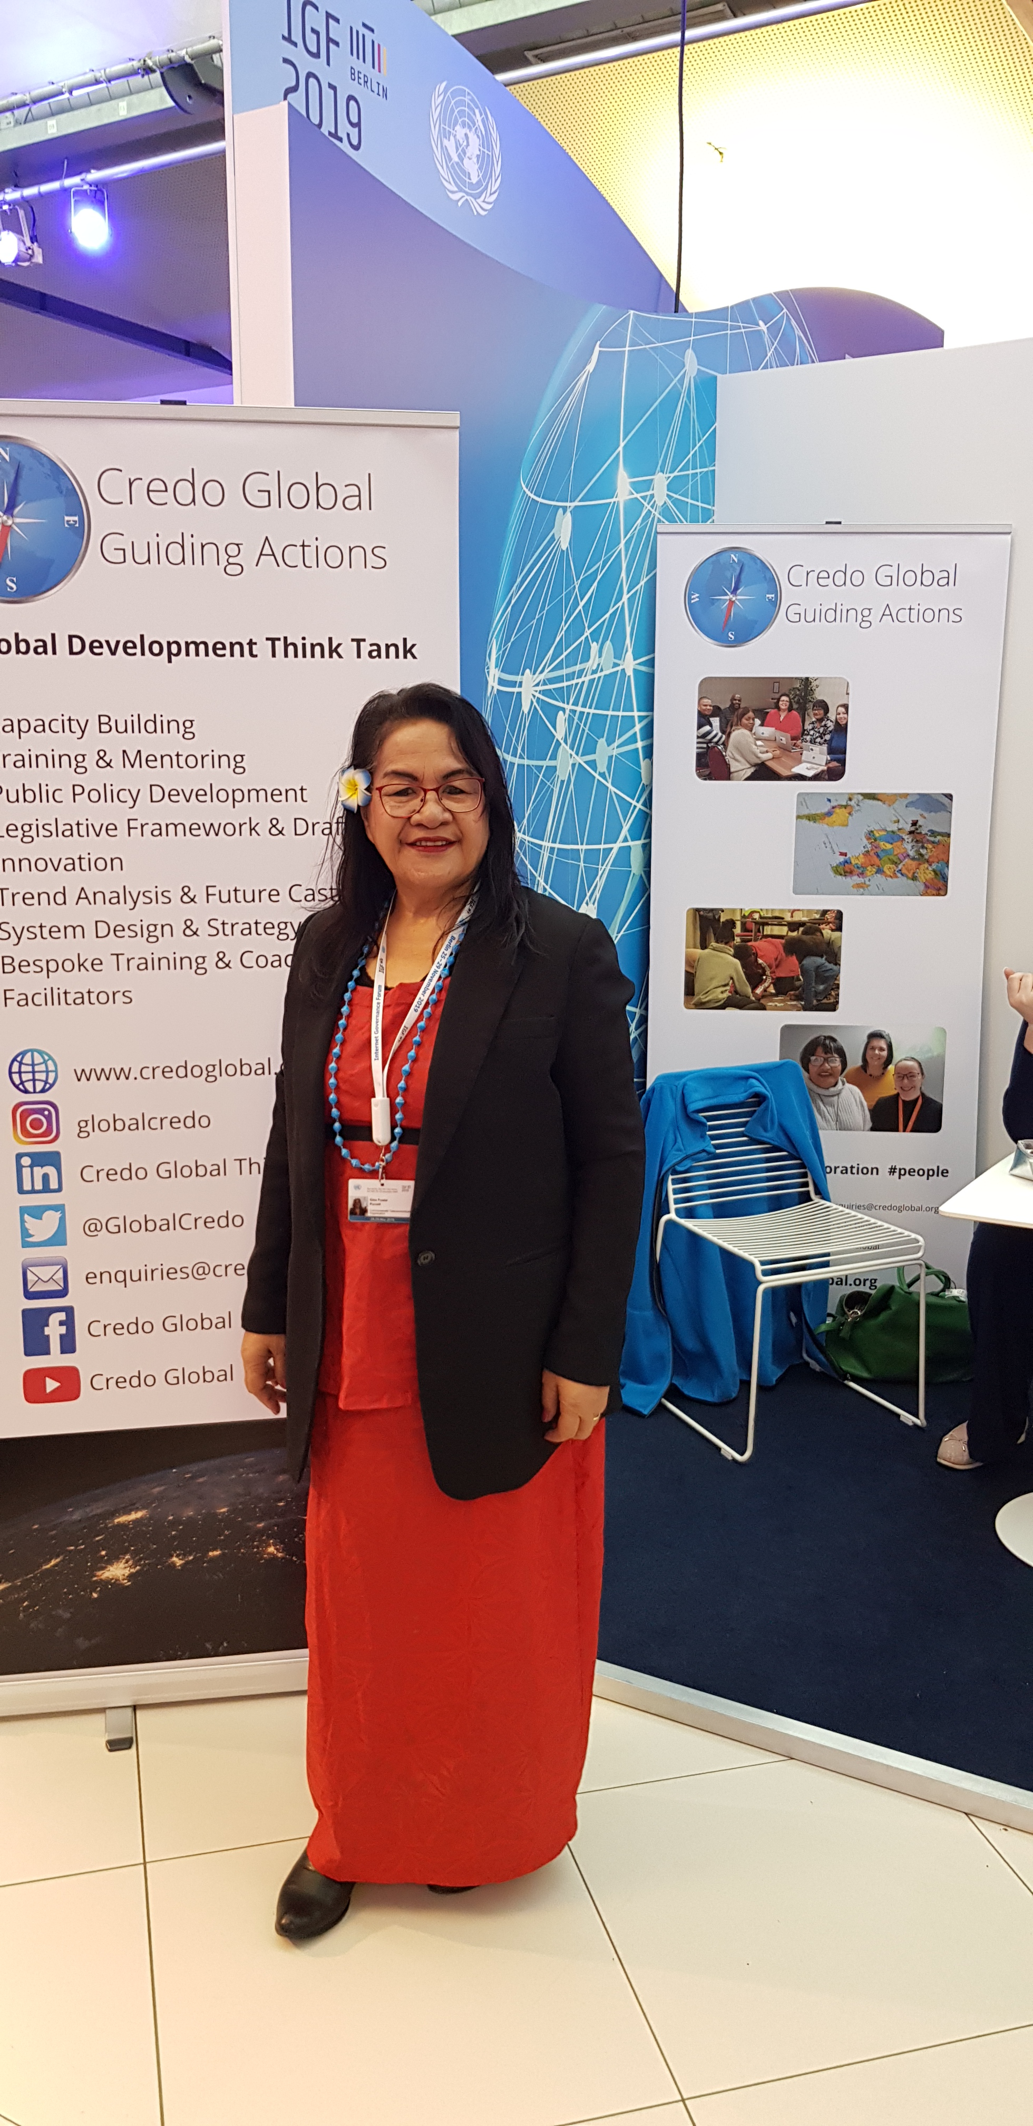

Pacific guests at the Launch of Credo Global in Berlin

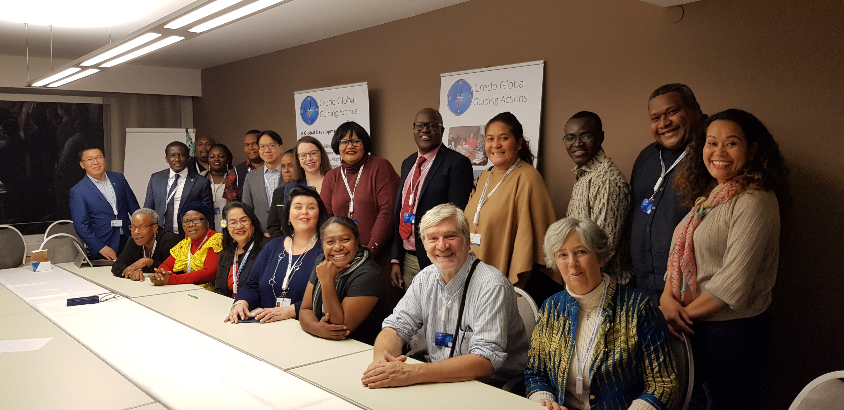

Hon. Gisa Fuatai Purcell, Commonwealth Telecommunications Organisation
Acting Secretary General

Guests from around the world at the Credo Global Launch

