Survival guide to Guadalajara

If you’re coming to the IGF in Mexico, this guide can help you navigate your way into the mysterious world south of the wall.

Where is the IGF?

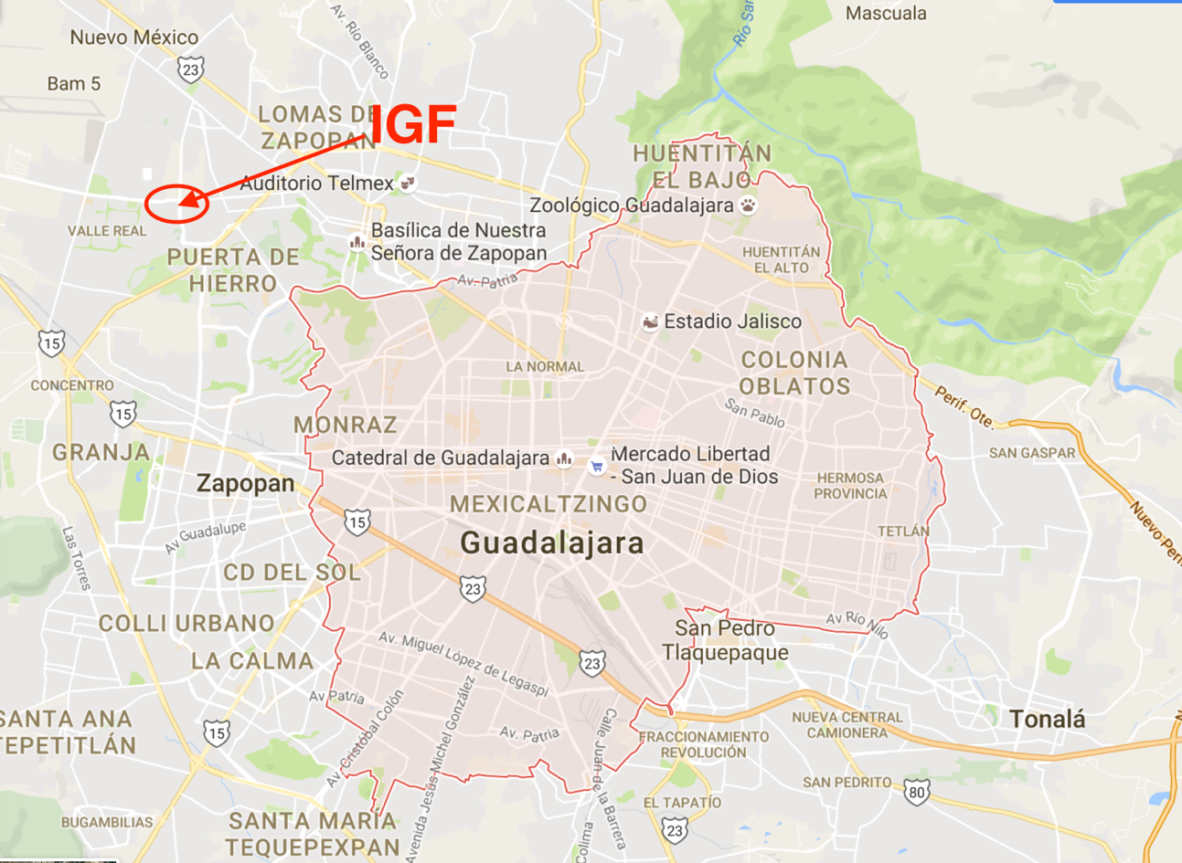
The IGF was originally going to be held in the City of Guadalajara, in the State of Jalisco, Mexico. Then, for some reason (unknown), it was changed to Zapopan. WHAT? ZAPOPAN? Where in the world is Zapopan?!?!?! Relax. Zapopan is just suburban Guadalajara so while you’re technically out of Guadalajara, you’re practically still within its suburban rim.

The venue for the IGF will be the “Palacio de la Cultura y de la Comunicación (PALCCO)” (location and website).

Where to stay?

The closest hotels to the venue are:

- Wyndham Garden Guadalajara Acueducto
- Hotel Real Zapopan
- Hotel Intercity
- Grand Fiesta Americana
- Aloft Guadalajara

Disclaimer- I have never stayed on any of the hotels listed so these are just listed as a reference but in no way as a recommendation.

Transport

When you get to the airport, you will have two transport options:

- Authorized Taxis (most expensive)
- Über (least expensive)

Be mindful that Über drivers are still struggling with taxi cabs. Sometimes taxi drivers may be aggressive to Über drivers or passengers. The best way to avoid this kind of situation is jumping in, in the front seat and riding along with your Über driver.

Safety

Guadalajara and its suburban area are a big city. As such, safety risks may be anywhere. Use your common sense. It will be your best friend. Enjoy the city. There are many beautiful places to see and explore. Relax. You will most likely be safe almost anywhere. Of course, avoid going out being flashy, avoid walking alone by night in dark places, avoid engaging with strangers that seem suspicious.

In case of emergency, dial 066. The operator may or may not speak English.

Airport Wi-Fi

Guadalajara’s airport offers free wi-fi under GAP FREE wireless network.

Power

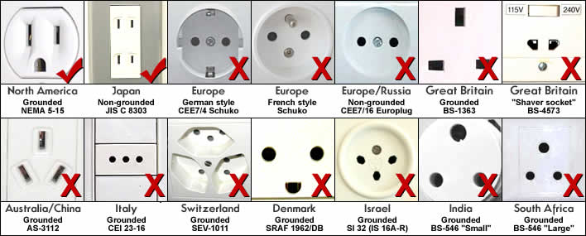
Mexico’s power supply operates on 110-120 volts.
Local SIM cards

There are 4 main mobile phone companies:

- Telcel
- Movistar
- AT&T
- Virgin Mobile

Any of those companies offer prepaid SIM cards. The two companies with the best coverage are Telcel and Movistar. Prepaid plans will vary in price but you will be able to get a good deal for between 8 to 20 dollars depending on your data needs.

I am not aware of any stores that sell SIM cards at the airport. In any case look for the company logo and ask if they have SIM cards available.

You can also try to look for convenience stores under the brand OXXO. There You may find SIM cards for sale.

Currency exchange

You will find currency exchange shops at the airport and in many places around the city. Rates may vary importantly between one shop and other so look at the different rates to see who pays you best for your foreign currency.

In my experience, withdrawing form ATMs offers you the best rate available.

Where to eat?

There are many good places to eat in Guadalajara and Zapopan. You can find a list of restaurants in Trip Advisor or you can try any of the restaurants featured in this list.

My favorite in that list are Anita Li, I Latina, Karnes Garibaldi and Tortas Toño. While Anita Li and I Latina might be a bit expensive, Karnes Garibaldi and Tortas Toño are affordable and will give you a good local eat.

Be mindful of hot salsa! If you have a “torta ahogada”, which I highly recommend you have, keep in mind that there are two types of salsa you can dip your torta into. The tomato salsa is NOT hot at all (promise) and is completely safe if you don’t like hot food. On the other hand, the red chili hot salsa is SUPER hot even for Mexican people used to eat hot salsa. So if you want to try the hot salsa, you can pour a bit of it in your torta and have it dip into tomato sauce too.

What to drink?

Tap water is not drinkable. You might want to buy bottled water instead. Some people even use bottled water to brush their teeth. I don’t so it’s really up to you if you want to risk it.

One word: Tequila! You’re in the birth land of Tequila so forget about any Tequila you’ve tried elsewhere. This is the real thing.

There’s a bus tour known as Tequila Express. Las time I checked there were no available tickets but you can keep checking at their website.

If you like craft beer, there are also a series of places to have good craft beer around Guadalajara. My favorite is Gaspar Hamburguesería.

If you have any questions, I’ll be happy to help. Send me a note to leonfelipe@sanchez.mx

