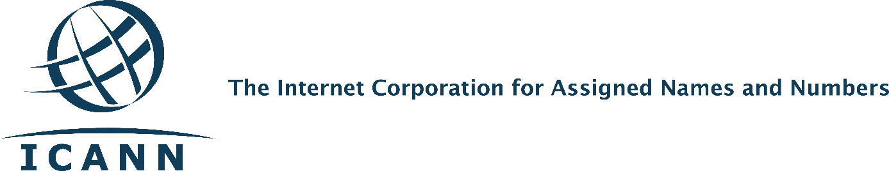
Important Update from Constituency Travel
ICANN Travel Provider Change Is Complete
On 31 March 2016, ICANN transitioned its travel support vendor from BCD Travel to FCM Travel Solutions. The move to FCM enables the Travel Team to continue to provide first-class customer service.
What’s New?
We have adopted a model that better serves our global community. FCM provides regional agents to give you email or phone support in your local time zone with more language options. You will have new travel tools, including an online travel portal with features such as:
- Contact information for FCM regional agents
- 24/7 access to the travel request link
- Management of traveler profile information (e.g., frequent flyer information)
- Language preference selection for the site (for most languages)
What’s Not New
There are no changes to ICANN travel policy guidelines.

Training Webinars
The Travel Team will host two training webinars for community members. The training will include how to use the new travel portal. We will also give you important FCM contact information.
The webinars are scheduled for 17 May at 12:00 UTC and 18 May at 20:00 UTC (details to be determined). Closer to the date, we’ll provide connection information to the SO-AC support teams to share with community members. You can also find information at: https://community.icann.org/display/trvlconstit/Constituency+Travel+Home.
Contact Us
Please direct any questions to: constituency-travel@icann.org.

