Trademark Clearing House Draft Implementation Model
What is a Trademark Clearing House?
The Trademark Clearinghouse is one of several important enhanced rights protection mechanisms that have been built into the new gTLD program. The Trademark Clearinghouse will accept and authenticate rights information, and will support both trademark claims and sunrise services, required in all new gTLDs. The Clearinghouse is expected to play an important role in the launch of the New gTLD Program and in ensuring ongoing protection of trademark rights.
Caveat
There were recordings of the meeting which will be posted. This summary is not meant to be relied on but to offer a perspective of an observer. It should also be noted that I was intermittently watching and observing. I would recommend that anyone interested in the matter make time to watch the recording and peruse the documents available on the website.
Why is this important for At Large?
This is important if you are a mark holder or there are people in your community that are mark holders and you want to protect and preserve certain marks. It is useful to understand the processes. There can be varying degree of interests and if your community is applying for a gTLD or if you have a mark and want to protect it. Or if you are just plain curious.
What was the meeting about?
The meeting was more to get input into the joint Neustar proposal that was submitted in Prague. At the close of the Prague meeting there was a lot of feedback and dynamic interaction. This Brussels meeting was very well attended both physically as well as remote participation. It was an open meeting
The Prague Meeting as a Context
Having attended the Prague meeting, I find that this was a huge step up from Prague and I learnt alot. The Draft Implementation Model that was published on 13th April 2012, see: https://community.icann.org/download/attachments/31176258/TMC-Model-Draft-13apr12.pdf?version=1&modificationDate=1334362955000
As you can imagine there was a lot of interactions from the floor on the draft and those tabling the proposal advised that they would be open to input. I must say that the meeting in Brussels was a huge step up from Prague.

Sala’s Summary of the Remote Streaming
The two day meeting was convened in Brussels and comprised of Registrars discussing the draft swimlane chart on a Trademark Clearing Model from the Applicant Guidebook and what essentially should be viable processes. The Draft Design Chart was discussed, and I have attempted to put the chart in and have not cropped it properly as it is 3am as I am writing this and I am not fully functional See the Annexure below.
I streamed in today [yesterday at 10pm and slept during the break and went back after midnight to follow the developments].
There were some clear distinctions between implications on design for Mark Holders who are not interested in time but are more interested in preserving their mark and for Registrars who want things done fast. It was also useful to hear the challenges that some face in relation to the way that the Guidebook is worded and there was some talk of suggested revisions.
The meetings [2 days] was recorded and will be available. I would recommend that Dev and his Team watch it. It is a good place to also understand some the challenges that registrars and resellers go through.
Hopefully the documents will be up via http://newgtlds.icann.org/en/about/trademark-clearinghouse It was eventually decided that Neustar would revise the paper they presented in Prague to include the feedback and comments coming in and it will be posted for comments although this does not preclude anyone from posting or submitting papers that will be open to comments etc etc It is also important to underscore that the paper is not an ICANN paper, it is a paper or proposal from the Industry at the moment (remember the one that was tabled in Prague) for those of us who attended the session.
I would recommend that the ALAC consider appointing a liaison and establishing a Working Group to monitor the development and assist the ALAC and At Large.

ANNEXURE
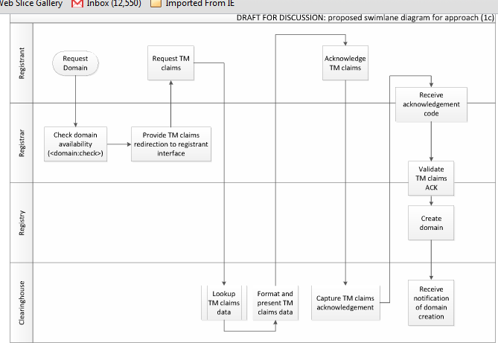

http://newgtlds.icann.org/en/about/trademark-clearinghouse
ibid
ibid
Neustar wrote the paper with someone else, a group I suspect but the audio was terrible and could not quite make out who it was

