2016 Nominating Committee Report Card #4
February-March 2016
Date: 2 April 2016

1) 105 candidates for leadership positions

During the application period for ICANN leadership positions 2016, a total of 105 completed applications were received. This is more than in 2015 (85) and just shy of the all-time record (110) in 2013. Some applicants are candidates just for one position, while others are interested in multiple openings.

There are 94 candidates for the Board, 40 for the GNSO Council and 37 for the ccNSO Council. For the ALAC, where this year there are open positions for representatives of EURALO and NARALO, there are 23 candidates: 9 from Europe and 14 from North America.

The graph below shows the geographic distribution (by ICANN region) and gender balance of the candidate pool.

Of the 105 candidates, 20 are women and 85 men. The gender balance has improved a little from 2015, when 14% were women, but certainly not enough, and the result is a lesson for subsequent NomComs to continue efforts for a better balance in the candidate pool.

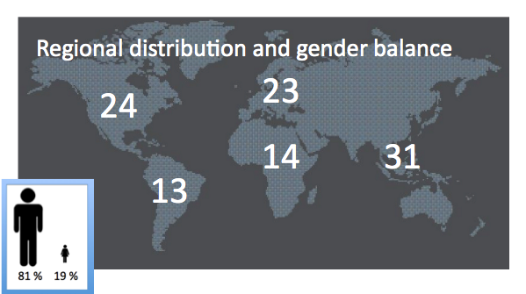
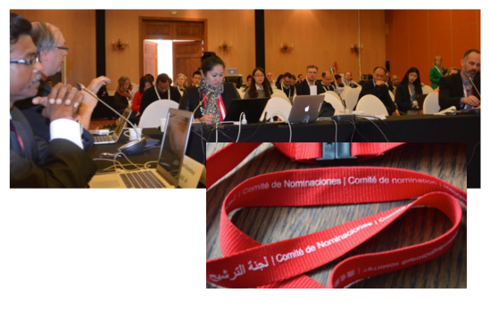

2) NomCom at ICANN 55 in Marrakech

At ICANN 55 in Marrakech, the members of the Nominating Committee continued outreach to the community, wearing their badges on special red lanyards to attract the attention of potential candidates.

The open meeting of the NomCom was a great success, with a record community participation both in terms of numbers (30-40) and of intensity of interaction, which would have lasted much longer than the allotted 75 minutes. The reason probably was that - unlike at previous ICANN meetings - the NomCom open meeting was held in a large room with a central location at the venue. As NomCom Chair Stéphane Van Gelder observed, "We've been campaigning so hard for years to have an open meeting in a room that would boost community participation rather than hinder it. Seeing our 75 minute meeting not get beyond our first agenda item because there was such a rich interaction with the community is a real testament to our perseverance at achieving this."

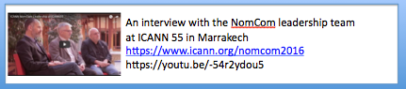

The Nominating Committee regularly meets with the Board Governance Committee (BGC) at all ICANN meetings, and Marrakech was no exception. One of standing issues at the BGC-NomCom discussions is elaborating and updating the advice from the Board regarding necessary skill sets and other requirements for Board members. No essential changes to the 2015 version were offered. The BGC stressed that advice is given to help NomCom in its work, but it is up to the Nominating Committee and nobody else to make the decision.

Another topic for discussion in Marrakech was the decision of the Board at its February 2 meeting to start discussions with the Nominating Committee and other electing bodies on how to implement the part of ATRT 2 recommendation 3 to the effect that "the Board should conduct quantitative/qualitative studies to determine how the qualifications of Board candidate pools change over time". NomCom members and staff explained that historical data for such studies are not available now. To protect the privacy of the candidates, the data on their applications are not carried forward from one NomCom to the next. To comply with the ATRT 2 recommendation, it is certainly possible from now on to gather anonymized statistics on candidate qualifications.

An important part of the NomCom agenda at the March meeting is to prepare the members for the intensive period of work that follows immediately when the application window closes and lasts until close to the June meeting. Several hours in Marrakech were spent in a detailed walk-thru of the assessment, straw polling and selection processes on the protected wiki pages and teleconferences. There was also training session on how to interview candidates.

The face-to-face meeting in Marrakech was also an opportunity for the NomCom to review and discuss elements of the some established NomCom procedures to make sure that they do work in the optimal way.

3) Meeting with Odgers Berndtson (OB-F)

NomCom invited representatives of the Frankfurt office of Odgers Berndtson, the recruitment firm that NomCom uses for assessing Board candidates, to its teleconference 29 March. OB-F has performed such services to successive NomComs since 2008.

At the meeting, OB-F experts explained their methodology in interviewing and assessing candidates, and in preparing the score cards for NomCom's use. All interviews are confidential, conducted in English, and last from one and half hour to two hours. They and considered as raw data for analysis. However, to better acquaint the NomCom with their methodology, OB-F will share with it the headlines of their battery of questions, but not the questions themselves, let alone the answers.

It was observed that the content of the score cards changes from year to year reflecting the needs of successive NomComs.

It was decided to have another joint NomCom - OB-F teleconference when the committee has received the score cards from OB-F.

4) Next steps

The NomCom has now started the most intensive phase of its work cycle, deliberating on the candidates and taking straw polls on its protected Wiki and on teleconferences April-June in order to winnow down the numbers in all candidate categories.

A limited number of Board candidates will be selected for telephone interviews and assessment by Odgers Berndtson (Frankfurt).

After further NomCom deliberations, shortlisted Board candidates will be invited to ICANN 56 (Helsinki, June 27-30, 2016) for face-to-face interviews. NomCom will hold its final selection meeting in Helsinki July 1 - 2. The selected candidates and the Secretary of ICANN are notified immediately thereafter.

In August/September, after due diligence has been performed, the NomCom makes a public announcement of the selectees. Selected nominees to the Board can attend the Board retreat September 15-17 in Istanbul, Turkey.

Selectees will take up their positions after ICANN57 (San Juan, Puerto Rico October 29 - November 4, 2016)

Appendix: 2016 NomCom essentials

Leaders to be selected

- Three members of the ICANN Board of Directors
- Two At-Large Advisory Committee (ALAC) members (one each from Europe and North America)
- One member of the Council of the Generic Names Supporting Organization (GNSO)
- One member of the Council of the Country Code Names Supporting Organization (ccNSO)

Committee Leadership:

Chair (chosen by the Board): Stéphane Van Gelder, Associate Chair (chosen by Chair): Wolfgang Kleinwächter, Chair Elect (chosen by the Board to prepare for the Chairmanship of the 2017) NomCom): Hans Petter Holen

Committee:

Voting members: Thomas Barrett (GNSO/Registrars SG), Steve Coates (GNSO/CBUC-Large), Eduardo Diaz (ALAC-NA), William Drake (GNSO/NCUC), Hartmut Glaser (ASO-AC), Zahid Jamil (GNSO/CBUC-Small), Dave Kissoondoyal (ALAC-AF), Yrjo Lansipuro (ALAC-EU), Sylvia Herlein Leite (ALAC-LAC), Osvaldo Novoa (GNSO/ISPCP), Amir Qayyum (ALAC-AP), Jörg Schweiger (ccNSO), Ellen Shankman (GNSO-IPC), Ken Stubbs (GNSO/Registries SG) and Tim Wicinski (IAB for IETF); Non-voting members: Alejandro Acosta (RSSAC), Mark Seiden (SSAC). ICANN Staff support: Joette Youkhanna, Jia-Juh Kimoto

Sub-committees:

SOI Revision Sub-Committee: Suggest improvements to the content design and language of the Statement of Interest forms. Chair: Steve Coates, Members: Zahid Jamil, and Thomas Barrett.

Application Software Sub-Committee: (Chair: Mark Seiden, members Amir Qayyum, Tim Wicinski, Zahid Jamil) to suggest improvements to the software currently used in the application process

Recruitment/Evaluation vendor Sub-Committee: Prepare for possible alternative recruitment partners to work with future NomComs, starting with the 2017 committee. Chair: Zahid Jamil, Members: Yrjö Länsipuro, Thomas Barrett, and Osvaldo Novoa.

Recommendations Sub-Committee: Review the recommendations from the 2015 NomCom and ensure the 2016 NomCom makes best efforts to enact them. Chair: Hans-Petter Holen, Members: Zahid Jamil, Tim Wicinski, and Eduardo Diaz.

Reference Communications Sub-Committee: Suggest improvements to the reference form. Chair: Bill Drake, Members: Dave Kissoondoyal, Jörg Schweiger, Eduardo Diaz, and Sylvia Herlein Leite.

Conflict of Interest Sub-Committee: Handle any declared conflicts of interest concerning a member of the NomCom. Chair: Wolfgang Kleinwächter, Members: Dave Kissoondoyal, Steve Coates, Zahid Jamil, Mark Seiden, and Ken Stubbs.

Travel logistics Sub-Committee: Suggest solutions to problems related to travel for face-to-face meetings (Visas, ICANN travel rules, etc.). Chair: Hartmut Glaser, Members: Zahid Jamil, Mark Seiden, Sylvia Herlein Leite, and Amir Qayyum.
Meetings:

Kick-off face-to-face meeting, Dublin, 23-24 October 2015.

In attendance: Chair; Chair Elect; Associate Chair; 5 ALAC; 2 CBUC; 1 RrSG;
1 RySG; 1 ISPCP; 1 ccNSO; 1 ASO-AC; 0 RSSAC; 1 SSAC; 0 IPC; 1 NCUC;
1 IAB for IETF. Apologies received from members unable to attend.

Meeting with the Board Governance Committee, 24 November, 2015.

In attendance from NomCom: Chair; Chair Elect; 0 Associate Chair; 5 ALAC;
2 CBUC; 1 RrSG; 1 RySG; 1 ISPCP; 1 ccNSO; 1 ASO-AC; 0 RSSAC; 0
SSAC; 1 IPC; 1 NCUC; 1 IAB for IETF. Apologies received from members
unable to attend.

Meeting 8 December, 2015.

In attendance; Chair; Chair Elect; Associate Chair; 5 ALAC; 2 CBUC; 1 RrSG;
0 RySG; 1 ISPCP; 1 ccNSO; 1 ASO-AC; 1 RSSAC; 1 SSAC; 1 IPC; 1 NCUC;
0 IAB for IETF. Apologies received from members unable to attend.

Meeting 21 January, 2016

In attendance: Chair; Chair Elect; Associate Chair; 3 ALAC; 2 CBUC;1 RrSG; 0 RySG; 1 ISPCP; 0 ccNSO; 1 ASO-AC; 0 RSSAC; 1 SSAC; 0 IPC; 0 NCUC; 1 IAB for IETF. Apologies received from members unable to attend.

Meetings at ICANN 55, Marrakech,6-10 March, 2016

In attendance: Chair; Chair Elect; Associate Chair; 5 ALAC; 2 CBUC (1 remotely); 1 RrSG;
1 RySG (remotely) ; 1 ISPCP; 1 ccNSO; 1 ASO-AC; 1 RSSAC (remotely); 1 SSAC; 1 IPC (remotely); 1 NCUC; 1 IAB for IETF.

Meeting with OB-F, 29 March, 2016

In attendance from NomCom: Chair; Chair-elect; Associate Chair; 3 ALAC; 1 RySG; 2 CBUC; 1 RrSG; 1 ccNSO; 1 ASO-AC; 1 ISPCP. Apologies from members unable to attend.
From OB-Frankfurt: Gabi Stahl, Regina Köhler, and Corina Strobel.

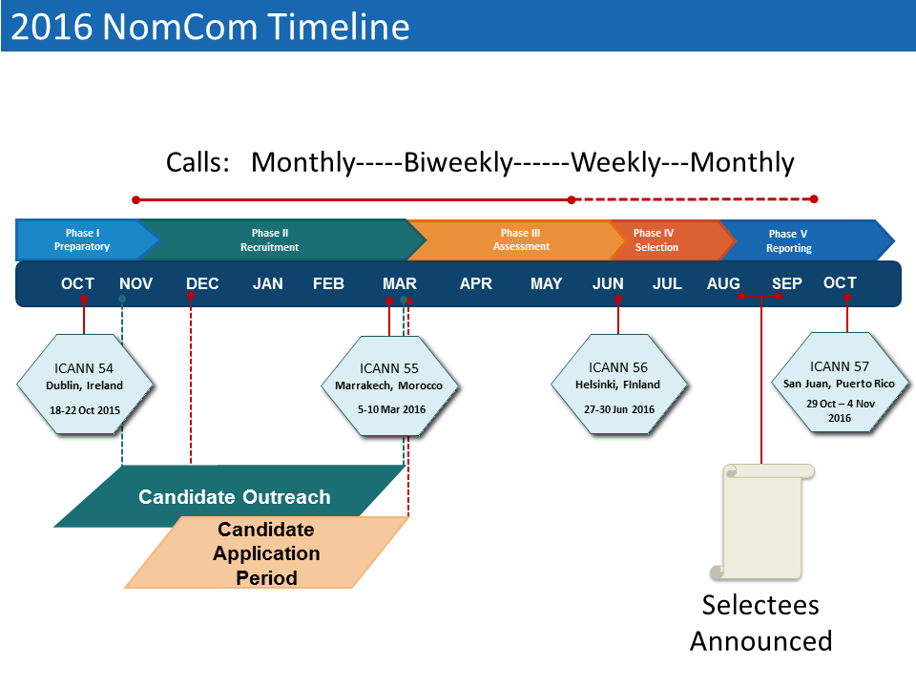

https://www.icann.org/en/system/files/files/nomcom-board-skills-advice-19oct15-en.pdf

