Nominating Committee Report Card #5

April-May 2015
Date: May 15

1) Intensive phase concluded

In April, the 2015 NomCom entered the most intensive phase of its cycle: straw polling and assessing the candidates, and shortlisting those to go to the next stage in the selection process. From mid-April until mid-May, the NomCom was meeting on a weekly basis, and concluded this work phase on schedule.

At the close of the application period, March 15, there were 81 candidates for the nine positions open in 2015. Some applicants applied just for one, while others indicated their interest for multiple positions.

There are 51 candidates for the Board, 38 for the GNSO Council and 29 for the ccNSO Council. For the ALAC, where in 2015 there are open positions for members from AFRALO, APRALO and LACRALO, a total of 41 candidates applied: 16 from Africa, 9 from Asia/Australia/Pacific and 16 from Latin America/Caribbean.

2) Shortlisting process

NomCom’s work schedule for this phase followed a pattern tested over many years, with some important improvements initiated by the 2015 NomCom. Each group of candidates – i.e., those for the Board, GNSO, ALAC and ccNSO – in their turn was given an initial evaluation by NomCom members using an improved straw poll platform on protected Wiki pages. Members graded each candidate

Each candidate was graded by each member on a five-point scale:

Outstanding (5 points)
Excellent (4 points)
Qualified (3 points)
Marginal (2 points)
Not recommended (1 point)

For each candidate, the staff calculated both the average grade and the variance, the latter figure indicating the degree of consensus among the committee.

The straw poll for each group of candidates was followed by a NomCom call where poll results were reviewed. Based on a list of candidates in the descending order of their averages, those that reached an average of 3.5 points were discussed at length. After deliberations, the committee decided, using the polling feature of Adobe Connect, which ones of each group were to the “green basket” i.e. the next stage of the selection process.

3) Straw polls and meetings

On the NomCom call 14 April, the committee discussed and agreed on the modalities of polling. Each group would be polled in one batch. In addition to the average of the candidate score, also variance would be calculated in order to demonstrate how the score is distributed among the members. The Staff was asked to set up the poll for Board members by 15 April, and members were to complete polling by 18:00 UTC on 20 April.

On the NomCom call 21 April, the committee selected 15 Board candidates for further assessment and telephone interviews by Odgers Berndtson (OB), a leading recruitment firm that has performed this task for NomCom since several years.
On 28 April, after polling the GNSO Council candidates on the Wiki, NomCom shortlisted seven for further consideration (“green basket”) and three to be held in reserve (“yellow basket”).

On 5 May, after polling ALAC candidates on the Wiki, NomCom made the following decisions concerning candidates from the three ICANN Regions with seats to be filled in 2015:

Africa: five candidates in the “green basket”, two in the “yellow basket”

Asia/Australia/Pacific: three candidates in the “green basket”, one in the “yellow basket”

Latin America/Caribbean: four candidates in the “green basket”, one in the “yellow basket”

On 12 May, after polling ccNSO Council candidates on the Wiki, NomCom shortlisted five of them in the “green basket” and held one in reserve in the “yellow basket”.

4) Next steps

In the next phase, starting in mid-May, NomCom members, working as pairs, are going to acquaint themselves in great detail with the applications and supporting material presented by 2-3 candidates assigned to each pair. This phase, also known as “deep diving”, may also include telephone interviews with candidates.

After their assessment by OB, the 15 Board candidates will be discussed by the NomCom in order to select those 7-9 to be invited to face-to-face interviews in Buenos Aires during ICANN 53, before NomCom’s final selection meeting 26-27 June.

Selections are announced in August/September, and selectees will take up their positions after ICANN’s Annual General Meeting (Dublin, October 18-22 2015)

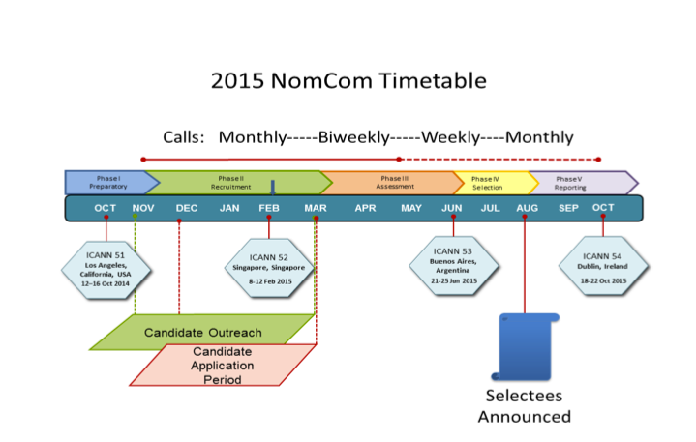

Appendix: 2015 NomCom essentials

Committee Leadership:
Chair (chosen by the Board): Stéphane Van Gelder; Associate Chair (chosen by Chair): Cheryl Langdon-Orr; Chair Elect (chosen by the Board to prepare for the Chairmanship of the 2016 NomCom): Ron Andruff

Committee:
Voting members: 5 ALAC; 1 ccNSO; 1 ASO; 1 IAB; 7 GNSO (RrSG, RySG, NCUC, ISPCP, IPC, CBUC [1 small / 1 large business rep]) Non-voting members: 1 SSAC, 1 RSSAC, 1 GAC
ICANN Staff support: Joette Youkhanna, Jia- Juh Kimoto

Sub-committees:
1. Conflict of interest (Chair: Cheryl Langdon-Orr)
2. Outreach and recruitment3 (Chair: Ron Andruff)
3. Transparency (Chair: Yrjö Länsipuro)
4. Wiki SOI revisions4 (Chair: Ron Andruff)
5. Alternates for unexpected vacancies (Chair: Cheryl Langdon-Orr)

Meetings (since the start of 2015 NomCom):

Kick-off face-to-face meeting in Los Angeles, 17-18 October, 2014

In attendance: Chair; Chair Elect; Associate Chair; 5 ALAC; 1 NCUC; 1 ISPCP; 1 ccNSO; 1 ASO; 0 IPC; 1 RrSG; 1 RySG; 1 SSAC; 1 RSSAC, 2 BC; 1 IAB for IETF. Apologies received from members unable to attend.

Teleconference 4 November, 2014

In attendance: Chair; Chair Elect; Associate Chair; 5 ALAC, 1 NCUC;1 ISPCP; 1 ccNSO; 1 ASO; 1 IPC; 0 RrSG; 1 RySG; 1 SSAC; 1 RSSAC, 2 BC; 0 IAB for IETF. Apologies received from members unable to attend.

Teleconference 2 December, 2014

In attendance: Chair; Chair Elect; Associate Chair; 5 ALAC, 1 NCUC;1 ISPCP; 1 ccNSO; 1 ASO; 1 IPC; 1 RrSG; 1 RySG; 1 SSAC; 0 RSSAC, 2 BC; 1 IAB for IETF. Apologies received from members unable to attend.

Teleconference 22 December, 2014

In attendance: Chair, Associate Chair, 5 ALAC, 1 NCUC, 1 ISPCP, 1ccNSO, 1 ASO, 0 IPC, 1 RrSG, 0 SSAC, 0 RSSAC, 2 BC, 1 IAB for IETF. Apologies received from members unable to attend.

Teleconference 28 January, 2015

In attendance: Chair, Chair Elect, Associate Chair, 4 ALAC, 1 NCUC, 0 ISPCP, 0 ccNSO, 1 IPC, 0 RrSG, 0 RySG, 0 SSAC, 0 RSSAC, 2 BC, 1 IAB for IETF. Apologies received from members unable to attend.

Face-to-face meeting at ICANN 52 in Singapore, 8 – 12 March, 2015

In attendance: Chair; Chair Elect; Associate Chair; 5 ALAC; 1 NCUC; 1 ISPCP; 1 ccNSO; 1 ASO; 1 IPC; 1 RrSG; 1 RySG; 1 SSAC; 1 RSSAC, 2 BC; 1 IAB for IETF.

Teleconference 1 April, 2015

In attendance: Chair, Chair Elect, Associate Chair, 5 ALAC, 1 NCUC, 1 ISPCP, 1 ccNSO, 0 IPC, 1 RrSG, 0 RySG, 1 SSAC, 0 RSSAC, 2 BC, 1 IAB for IETF. Apologies received from members unable to attend.

Teleconference 14 April, 2015

In attendance: Chair, Chair Elect, Associate Chair, 3 ALAC, 1 NCUC, 1 ISPCP, 0 ccNSO, 0 IPC, 1 RrSG, 0 RySG, 1 SSAC, 0 RSSAC, 2 BC, 0 IAB for IETF. Apologies received from members unable to attend.

Teleconference 21 April, 2015

In attendance: Chair, Chair Elect, Associate Chair, 5 ALAC, 1 NCUC, 1 ISPCP, 1 ccNSO, 1 ASO, 0 IPC, 1 RrSG, 0 RySG, 1 SSAC, 0 RSSAC, 1 BC, 1 IAB for IETF. Apologies received from members unable to attend.

Teleconference 28 April, 2015

In attendance: Chair, Associate Chair, 4 ALAC, 1 NCUC, 1 ISPCP, 1 ccNSO, 1 ASO,
1 IPC, 1 RrSG, 0 RySG, 1 SSAC, 0 RSSAC, 2 BC, 1 IAB for IETF. Apologies received from members unable to attend.

Teleconference 5 May, 2015

In attendance: Chair Elect, Associate Chair, 5 ALAC, 1 NCUC, 1 ISPCP, 1 ccNSO, 0 ASO,
0 IPC, 1 RrSG, 0 RySG, 1 SSAC, 0 RSSAC, 1 BC, 1 IAB for IETF. Apologies received from members unable to attend.

Teleconference 12 May, 2015

In attendance: Chair, Associate Chair, 4 ALAC, 1 NCUC, 1 ISPCP, 1 ccNSO, 0 ASO,
1 IPC, 0 RrSG, 0 RySG, 1 SSAC, 0 RSSAC, 2 BC, 1 IAB for IETF. Apologies received from members unable to attend.

