Community Consultation on ICANN Public Meetings: Recommended Strategic Changes for Future Meetings

This has been an undeniably challenging year; in many ways we could have never predicted. The virtual format for ICANN Public Meetings has forced both staff and the ICANN Community to look at how we work and consider new ways to foster effective communication and come together to achieve our common goals.
As a result, the ICANN Board initiated a consultation on ICANN Public Meetings with Community Leaders and hosted a public session during ICANN69 Annual General Meeting to facilitate community-wide engagement in the discussion.
Community feedback was also solicited through a detailed survey focused on identifying strengths and weaknesses in the current meeting strategy, potential areas for improvement, and important considerations related to the eventual return to face-to-face meetings.
The ICANN Public Meeting Strategy Survey included the following scope of topics for community feedback:
- Overall effectiveness of both in-person and virtual public meetings
- Number of ICANN meetings per year
- Objectives of the meeting schedule
- Time zone of virtual meetings
- Remote participation services
- Outreach and capacity building
ICANN org collected 176 responses to the initial survey, then asked Leaders from each ICANN Supporting Organization and Advisory Committee to work with their groups to develop a consolidated response.
This document outlines the resulting recommendations based on community survey responses. For all recommendations in this proposal, subject to Board approval, the anticipated launch for implementation would be for the ICANN70 Community Forum in March 2021.
Summary of Key Findings from the Survey
Survey responses are consistent with the comments we heard during the public session at ICANN69 and our analysis of the data identifies key points about community attitudes toward the ICANN Meetings that will inform how we can strengthen the overall strategy for public meetings.
The following key points have been identified:
- Continue the three-meeting schedule annually but increase concentrated time for cross-community policy work.
- Reduce session overlap and conflicts to allow more opportunity for community-wide participation.
- Determine goals and overall meeting objectives early in the planning process to facilitate more effective engagement and progress during the meetings.
- Increase time for networking and develop better tools to support networking opportunities during virtual meetings.
- Increase visual/video/graphic elements and encourage use of video cameras by all participants.
- Add trained session facilitators.
- When virtual, reduce the meeting length (fewer days/fewer hours per day) to prevent volunteer burnout.
- Rotate the time zone for meetings among ICANN’s five geographic regions.
Proposed Enhancements to ICANN Public Meetings Based on Community Recommendations
- SO/AC work sessions and intersessional meetings spread throughout the year to make more efficient use of time.
  - Reduces stress on the schedule and prevents volunteer burnout during the public meetings.
  - Eliminates session conflict and allows public meetings to focus on cross-community interaction and policy development work.
  - Creates more flexibility to schedule other sessions throughout the year in preferred time zone.
- Development of a unified online calendar for the community to populate with all SO/AC work sessions and intersessional meetings to provide greater opportunity for community participation.
  - Continued technical support for virtual participation of select sessions throughout the year.
- Enhanced networking opportunities and tools
  - Non-conflicted networking sessions following each plenary session to allow time for further community discussion on important topics
  - Ability to engage in discussion boards directly from session webpages
  - Ability to request and schedule one-on-one meetings with all publicly registered attendees
- Trained staff facilitators for interactive sessions during the public meetings.
Meeting Structure
- One session for SO/AC Updates to the ICANN Board
  - Opportunity for each SO/AC to brief the ICANN Board and community on current work
  - 10 minutes per group (9 total groups)
- Three sessions for Cross-Community Policy Development Work
- Three plenary sessions designed to be interactive and inclusive
- A Public Forum for community comment and Board response

Draft Block Schedule |  |  |  | DAY 1 | DAY 2 | DAY 3 | DAY 4
Block | Dur | UTC | CST (UTC-6) | Mon  22 March | Tue  23 March | Wed  24 March | Thu  25 March
1 | 90 | 16:00-17:30 | 10:00-11:30 | SO/AC Updates | Cross-Community Policy Work | Cross-Community Policy Work | Cross-Community Policy Work
2 | 45 | 17:30-18:15 | 11:30-12:15 | Networking 1 | Networking 1 | Networking 1 | Networking 1
3 | 90 | 18:15-19:45 | 12:15-13:45 | Plenary Session | Plenary Session | Plenary Session | Public Forum
4 | 45 | 19:45-21:00 | 13:45-15:00 | Networking 2 | Networking 2 | Networking 2 | Networking 2
Note: ICANN70 Community Forum shown above is for illustrative purposes.
Time Zone
For Virtual ICANN Meetings, survey results indicate a preference to rotate the time zone through ICANN’s five geographic regions:
- Africa
- Asia/Australia/Pacific
- Europe
- Latin America/Caribbean
- North America
The schedule will be planned during general working hours of the assigned region for each meeting.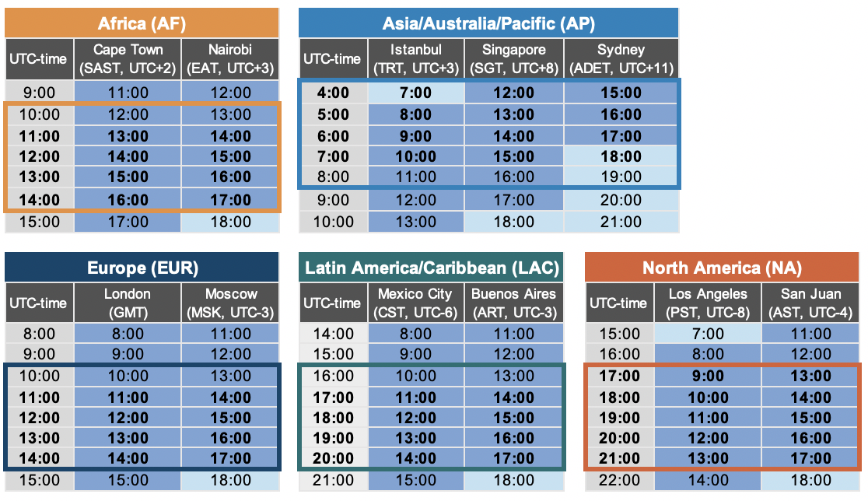
Regional Face-to-Face Meetings
Where pandemic conditions allow:
- Regional meetings on specific topics or issues to support regional/sectional community engagement and networking opportunities
- Regional hub meetings during Virtual ICANN Meetings
Implementation
The recommended strategic changes to ICANN Public Meetings will apply to all phases outlined in the attached Draft Proposal for Phased Return to Face-to-Face Meetings (Phase 0 through Phase 3).
- During Phase 2, the schedule will include the sessions outlined in Phase 0 but held in person at the meeting venue.
- Face-to-face SO/AC-specific working sessions and additional cross-community sessions will be added to the schedule as requested.

Original Draft Proposal for Phased Return to Face-to-Face Meetings

This draft proposal outlines a four-phased approach for returning to face-to-face ICANN meetings. Each phase suggests an enhanced remote participation experience, providing a more robust option for those not able to attend a meeting in person. The strategy emphasizes partnership and collaboration between the ICANN community and the collective org. ICANN org will continue to provide up-to-date assessment reports for each potential meeting location for community review and updates to the framework as needed.

Recommended dates for each phase will be established by the community and subject to change based on global conditions. Actual dates of transition between phases will be decided by the ICANN Board.

ICANN org will initiate necessary measures to minimize risk associated with face-to-face meetings. These will include the Core Actions outlined below.

Core Actions
- Physical Distancing
- Maintain required physical distancing
- Practice Good Hygiene
- Wear a cloth face covering (mask)
- Wash your hands, especially after touching frequently used items or surfaces
- Self-Quarantine
- People who feel sick or have been told to isolate/quarantine should stay home
- Higher-Risk Individuals
- Higher-risk individuals must consider their own personal safety while attending face-to-face meetings.

Note: Additional safety measures may be required to meet local government regulations at the time of the meeting.
Four-Phased Strategy Overview

Note: Recommended dates for each phase will be established by the community and subject to change based on global conditions. Actual dates of transition between phases will be decided by the ICANN Board.

Phase 0: No Face-to-Face Meetings
ICANN meetings taking place during Phase 0 will be held as online-only virtual events. For that reason, we will build an enhanced virtual meeting experience which allows for increased interaction, attracting more participants and offering engaging networking opportunities.
Objectives
- Ensure community participation and interaction
- Ensure SO/AC structures have sufficient support
- Support outreach needs as required by the community
- Maintain engagement of current community members
- Identify and support community networking opportunities
- Provide enhanced capacity development opportunities
- Deliver an enhanced virtual meeting experience

Remote Participation Services in Use Today
- Zoom Conferencing Platform
- Simultaneous Interpretation in 6 UN languages + Portuguese for GAC
- Real-Time Transcription (Live-Scribing)
- Post-Meeting Recordings and Transcripts
Enhanced Virtual Meeting Experience Recommendations
- Daily pre-recorded videos
- Pre-session highlights (daily newsletter)
- Pre-recorded sessions
  - Welcome Ceremony and Newcomer Session
- Enhance prep sessions
- Increased and better visual/video/graphic elements
- Add trained meeting facilitators
- Encourage use of video cameras by all participants
- Consider additional languages for simultaneous interpretation to increase participation
- Establish networking opportunities
  - Virtual coffee Break
  - Virtual cocktails
- Newcomers Engagement Virtual Booth
- Sponsorship opportunities
  - Exhibition hall
  - Virtual backdrop
  - Giveaways to be shipped

Phase 1: Hybrid Regional and Sectional Meetings
ICANN meetings and events during Phase 1 may still be taking place in an environment in which different regions and modes of travel have different risks. There will be attendees unwilling or unable to travel for a variety of reasons. We built in the option of a hybrid model into our planning; allowing for some local, regional, or limited in-person presenters and attendees while also accommodating an enhanced remote participation option for those who wish to present, participate, and engage remotely.

Objectives
- Ensure safe and secure face-to-face meetings for regional or sectional groups
- Ensure SO/AC structures, Review Teams, Working Groups, etc., have required support
- Support regional outreach needs as required by the community
- Maintain regional engagement of current community members
- Identify and support regional/sectional community networking opportunities
- Provide enhanced regional capacity development opportunities
- Continue providing enhanced Virtual meeting experience
Decision Making Process
Meeting Requesters
- Community (through appropriate channel, e.g., SO/AC leadership or ICANN org staff support for a specific Review Team or approved special project)
- ICANN Board
- ICANN Org

Meeting Criteria Review Team
- After budget/need for meeting confirmed, then …
- Requester identifies logistical requirements
- ICANN Meetings Team identifies appropriate venues
- ICANN Security Operations establishes health and safety guidelines

Meeting Decision Authority
- ICANN CEO, with advice from:
- ICANN Meetings Team
- ICANN Security Operations
- Responsible ICANN Executive Team Member
Phase 1 Meeting Criteria
- Respective country Covid-19 data/trends at the time of review
- Respective country government guidelines during requested meeting dates
  - Delegate count does not exceed attendance and personal distancing guidelines
- Health system capability
- Acceptable location and venue risk assessment
- Flight availability
- Visa availability and degree of openness
- Available budget
- Need for meeting confirmed by responsible executive
Logistic Measures for Phase 1 Face-to-Face Meetings
- Venue selected complies with hygiene, health and safety standards
- Set up according to physical distancing rules in public areas and meeting rooms
- Collaborate with the community to develop meeting room configurations that meet their needs while adhering to government social distancing requirements.
- Safe catering services
- Screening at the meeting room access point
- Certified paramedic onsite
- Face masks and sanitizer distribution at the entrance of meeting room

Phase 2: Hybrid ICANN Public and Other Large Meetings
ICANN meetings and events continue in a hybrid manner with a larger number of attendees; allowing for more global, in-person presenters and delegates while accommodating an enhanced remote participation option for those who wish to present, participate and engage remotely.
Objectives
- Ensure safe and secure face-to-face meetings with limited number of global attendees
- Ensure SO/AC structures and multistakeholder process have required support with physical attendance and interaction
- Support regional outreach needs as required by the community
- Maintain global engagement of current community members
- Identify and support community networking opportunities
- Provide enhanced capacity building opportunities
- Continue providing enhanced Virtual meeting experience
Decision Making Process
Meeting Requesters
- Community (through appropriate channel, e.g. SO/AC leadership or ICANN org staff support for a specific Review Team or approved special project)
- ICANN Board
- ICANN Org

Meeting Criteria Review Team
After budget/need for meeting confirmed, then …
- Requester identifies logistical requirements
- ICANN Meetings Team identifies appropriate venues
- ICANN Security Operations establishes health and safety guidelines

Meeting Decision Authority
- ICANN CEO with ICANN Board Advice
Phase 2 Meeting Criteria
- Respective country Covid-19 data/trends at the time of review
- Respective country government guidelines during requested meeting dates
  - Delegate count does not exceed attendance and personal distancing guidelines
- Health system capability
- Acceptable location and venue risk assessment
- Flight availability
- Visa availability and degree of openness
- Available budget
- Need for meeting confirmed by responsible executive
Logistic Measures for Phase 2 Face-to-Face Meetings
- Venue selected complies with hygiene, health and safety standards
- Set up according to physical distancing requirements in public areas and meeting rooms
- Collaborate with the community to develop effective meeting room configurations while adhering to current physical distancing requirements
- Safe catering services
- Screening at meeting room access points
- Certified doctor and paramedic availability onsite
- Distribution of face masks and sanitizer at the entrance of all meeting rooms

Phase 3: ICANN Public and Face-to-Face Meetings
ICANN meetings and events in Phase 3 continue in a hybrid manner with the usual number of ICANN meeting attendees; allowing global, in-person presenters and attendees while accommodating a strong remote participation option for those who wish to present, participate and engage remotely. We still expect the Core Actions to be followed, and for the Phase 1 and Phase 2 meetings criteria to be applied in Phase 3.
Objectives
- Ensure safe and secure face-to-face meetings for global attendees
- Ensure SO/AC structures and multistakeholder process have required support for physical attendance and interaction
- Support regional outreach needs as required by the community
- Maintain global engagement of current community members
- Develop and support community networking opportunities
- Provide enhanced capacity building opportunities
- Continue providing enhanced virtual meeting experience

Sectional meetings include SO/ACs, ICANN Board, Working Groups, Topical, etc.

