Remote Simultaneous Interpretation integrated into Zoom.

Accessing Interpretation

- Download the Zoom application to your computer or mobile device at https://zoom.us/download.
- Join the Zoom Meeting by clicking on the Zoom link in the invite.
- Follow these steps to listen to the interpretation:

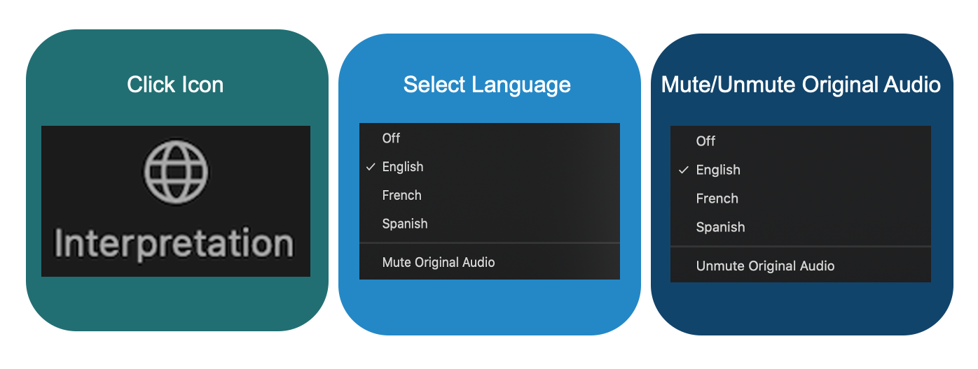

Speaking During the Session

- If you would like to ask a question or make a comment in one of the supported languages, raise your virtual hand in the Zoom platform.
- Select the language you will speak by clicking on the “Interpretation” icon on the toolbar.
- When called upon, unmute your microphone in Zoom. State your name for the record, the language you will speak, and ask your question or make your comment.
- Mute notifications from all other platforms or devices.
- When you are done speaking in the Zoom session, mute or disconnect Zoom audio and listen to the language of your choice.
- Please note that if you will be speaking a language other than the language you are listening to, you must change your selection each time you speak to ensure interpretation can be heard by other participants.
- In the event a speaker does not select their language channel, they may still be heard by selecting Unmute Original Audio.

