RICTA Virtual Workshop
RICTA (Rwanda Internet Community & Technology Alliance) - the entity managing the RW registry in
partnership with both AfTLD and ICANN is running virtual workshops to educate the Registrars and Internet Community at large in Rwanda! The workshops are not limited to the local community but are open to all ccTLDs of Africa. The aim of the webinars is to create awareness on how the community can benefit from the local ccTLD during the pandemic and to equip registrars and resellers with relevant skills needed for Domain Name Business. On 19 November 2020 RICTA held a session to discuss “ DNS Entrepreneurship” Panelists were Mr. Neil Dundas co-founder & CEO of DNS Africa, Mr. Olusegun Akinwunmi Web Services Administrator at Nigeria Internet Registry Association (NIRA) and Ms. Hadia El Miniawi Chief Expert at NTRA. Mr. Bob Ochieng, Sr. Manager, stakeholder Engagement – Eastern & Southern Africa from ICANN moderated the session.
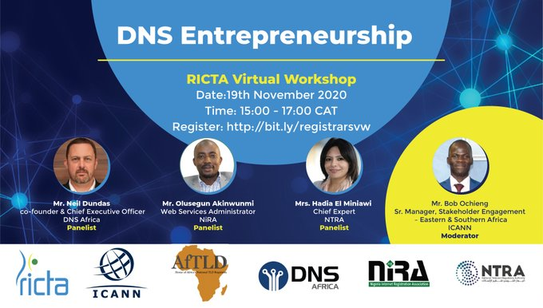

Hadia ElMiniawi

