ICANN 2021 NomCom is looking to Fill Nine Leadership Positions
The ICANN Nominating Committee (NomCom) is looking to fill nine positions for key leadership positions within ICANN. The NomCom is looking for leaders who represent diverse cultural, geographical, and professional backgrounds, while striving for gender balance.
If you are a critical thinker, with cultural awareness, knowledge of the Internet ecosystem with board or executive experience and a background in legal, government, technology, business or Non-Profit the NomCom is looking for you.
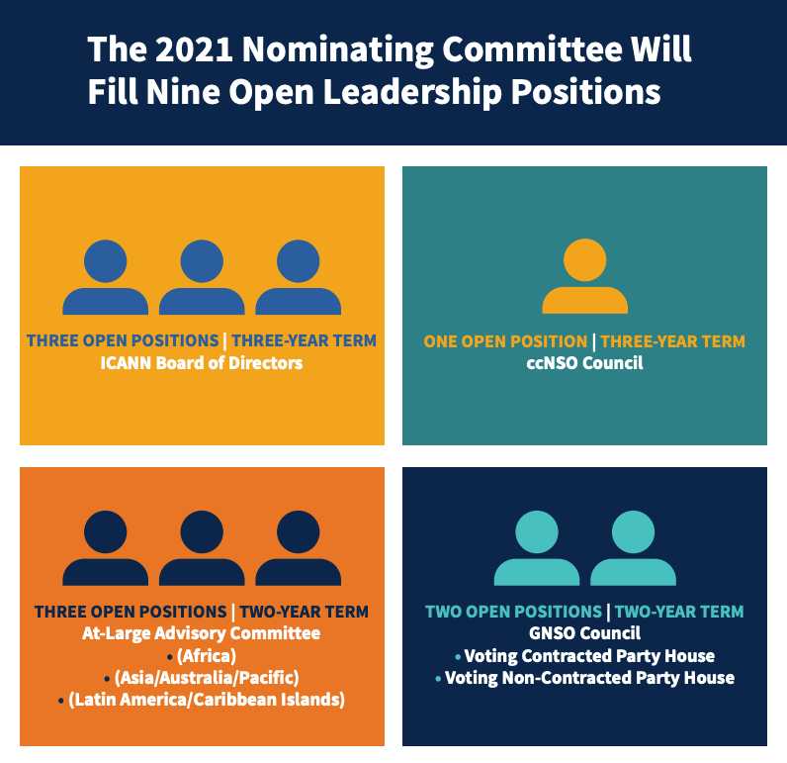
As an ICANN leader, you can influence the global Internet policy, affect the evolution of the Internet, develop professional skills, collaborate with a diverse group of industry leaders and engage with a global community.
For more information, please visit https://www.icann.org/nomcom2021

Hadia ElMiniawi
ALAC AFRALO NomCom Representative

