ICANN 2020 NomCom is looking to fill Seven Leadership Positions
The ICANN Nominating Committee (NomCom) is looking to fill seven positions for key leadership positions within ICANN and Public Technical Identifiers (PTI), an affiliate of ICANN organization. NomCom is looking for leaders who represent cultural, geographical, and professional background, while striving for gender balance.
If you are critical thinker, with cultural awareness, knowledge of the internet ecosystem with board or executive experience and a background in legal, government, technology, business or Non-Profit the NomCom is looking for you.
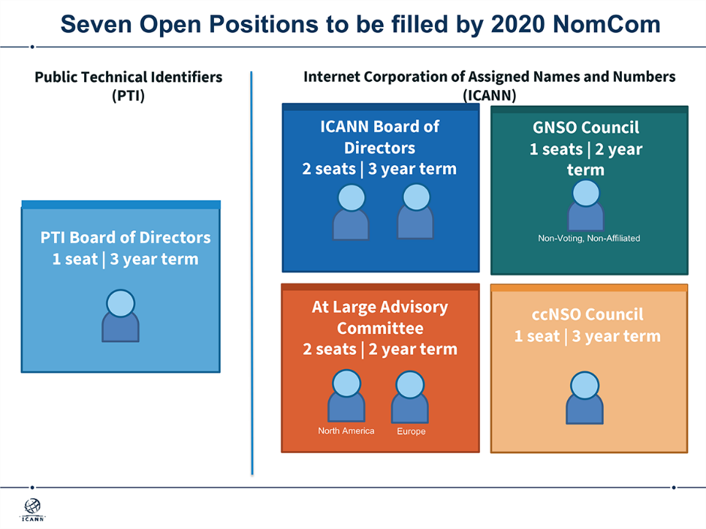
As an ICANN or PTI leader, you can influence the global Internet policy, influence the evolution of the Internet, develop professional skills, collaborate with a diverse group of industry leaders and engage with a global community.
To apply submit your application through the online candidate portal.
Hurry up the deadline is 18th of February 2020 at 23:59 Universal Coordinated Time (UTC).

Hadia ElMiniawi
ALAC AFRALO Representative

