AFRALO Hot Topics Report 2018

Introduction
This document aims to provide an overview of key policy issues that AFRALO has been working on and will focus as priority topics in ICANN, as well as the key outreach and engagement activities.
AFRALO is the home of the individual Internet user community for the African region. It provides news, key resources and interactive information sharing tools for individuals and end user groups in the African region who are interested in ICANN and in shaping the future of the Internet.
AFRALO main objectives are:
- Strengthen users’ participation in ICANN decision-making structures
- Help ensure that its members will actively encourage more direct participation by end users
- Build Internet policy making capacity in Africa
- Reach out to Internet users on the issues in the scope of ICANN
- Represent users’ interests and defining public interest aspects of Internet governance with specific focus on the areas of privacy, transparency, and accountability
- Strengthen consumer protection in ICANN policies
- Take cultural diversity into account when developing policies and formulating technical standards (e.g. IDN implementation)
AFRALO currently consist of 54 ALSes located in 30 countries and territories.

Hot Policy Topics Selected :
- Promoting DNSSEC Implementation in Africa's TLD registries
- New gTLDs and Geographic names
- New gTLD Subsequent Procedure
- General Data Protection Regulation (GDPR) and Privacy
- Registration Directory Service (RDS) and Whois
- ICANN's Accountability and Transparency
- Diversity and Participation at ICANN
- Internet Governance activities and issues
- Capacity Building, Awareness and Outreach to Africa ( e.g Access of ICANN materials in African/Other languages other than English )

Top Topic Issues
Promoting DNSSEC Implementation in Africa's TLD registries
Summary
DNSSEC is important because it adds security to the Domain Name System (DNS) protocol by enabling DNS responses to be validated. Specifically, DNSSEC provides origin authority, data integrity, and authenticated denial of existence.
Why its important to AfRALO and African Internet Users ?

Africa has a low DNSSEC implementation compared to the rest of the world.
Action Items
Promote DNSSEC and raise awareness among African ALS about the importants of DNSSEC implementation in their ccTLD registries.

Coordinate with ICANN and AfTLD in organizing DNSSEC session for AfRALO ALSs

New gTLDs and Geographic names
Summary
Africa now has its own TLD (.Africa) and some city geographical “GeoTLDs”, The protection of geo names raises many technical and public policy issues. The uses of geo. names, either as a Second-Level Domain names (SLD), or as a Top-Level Domain name (TLD), raise sovereignty and socio-economic concerns for many stakeholders including governments.
In ICANN’s policy development discussions, this issue has proved to complex, multi-layered and had disputed cases for many years. There are currently multiple strands of discussion under the heading of “geographic names”, in which the GAC involved to some extent, with a varying degree of concerns.
Why its important to AfRALO and African Internet Users ?
Many Geo. TLDs may face a challenge related jurisdiction and ownership. With reference to the policy Development processes, African Internet Users need to understand issues related to Geo. TLDs, the process in management of the gTLDs and the right of ownership or use of geographical names affect the Internet end users.
Action Items
Conduct a periodic webinars to AFRALO members to get insight into the New gTLDs and Geographic names and participate actively in the relevant policy development within ICANN.

Registration Directory Service (RDS) and Whois
Summary
RDS and Whois are pertinent issues that relate to the ownership of Domain names. Currently information on Domain ownership are published publicly. There is a strong drive to protect registration data and improve accuracy and access to generic top-level domain registration data, as well as consider safeguards for protecting such data.
Why it's important to AfRALO and African Internet Users ?

In the current RDS and Whois WG there is little participation from Africa despite the issue being relative to the Internet and Domain System in the region. Africa has the fastest rate of Internet user’s growth in the world.The fact that the pertinent issues that affect the registry have less reports coming from Africa Region and documentation regarding the violation of Whois records that are publicly limited - there is a need for strong awareness of the issues related to Whois, ICANN’s policy discussion and recommendations given which could affect the RDS implementation in Africa.
Action Items
Promote RDS - Whois and raise awareness among African ALS about the importance of RDS implementation.
Coordinate with ICANN and GNSO - RDS WG to have a session to explain the relevance of AFRALO participation in the RDS PDP
Request members from AFRALO who are passionate and willing to join the WG to become members to enhance African views and contribute to the Policy recommendations
More information on the RDS can be found https://www.icann.org/resources/reviews/specific- reviews/whois

ICANN's Accountability and Transparency
Summary
ICANN’s core mission is to coordinate, at the overall level, the global Internet’s systems of unique identifiers, and in particular to ensure the stable and secure operation of the Internet’s unique identifiers.
ICANN operates on a multi-stakeholder model that brings all interested parties together to discuss policy issues that fall within ICANN’s areas of responsibility. It follows a bottom-up model of policy development and relies on consensus from its stakeholders. For this model to operate effectively, ICANN needs to encourage participation, instill trust, make information accessible, and have sound dispute and review mechanisms.

ICANN believes that transparency and accountability are the foundations that support these elements in its operating the multistakeholders model.
Why its important to AfRALO and African Internet Users ?
Afralo and African Internet Users need to understand ICANN’s multistakeholder process and how it ensures Accountability and Transparency.
Action Items
Conduct a session(s) on the processes to engage members to understand clearly the Accountability and Transparency Processes.
Seek feedback on the current Accountability and Transparent Process

Gender Diversity and Participation at ICANN

Summary
The ICANN organization conducted the Gender Diversity and Participation Survey to gain insight into current perceptions of gender diversity within the ICANN community, to identify potential barriers to participation, and to gather data to help inform ongoing community discussions on diversity
Why its important to AfRALO and African Internet Users ?
Following the release of the report https://www.icann.org/en/system/files/files/gender-survey- complete-11oct17-en.pdf , it is important for AFRALO and African Internet Users be encouraged to participate in ICANN Policy Development Processes. This also follows the low participation and engagement from the Africa Region in the policy development process.
Action Items
Conduct a Gender Diversity Assessment of the engagement of AFRALO Members Coordinate with ICANN and Regional Leaders to explore new ways to enhance engagement from Africa.

General Data Protection Regulation (GDPR) and Privacy
Summary
The current state of the GDPR and privacy laws in the regions has been so neglected and with minimum or least participation Africa remains vulnerable to Global policies and does not have a proper stand when it comes to the GDPR. The GDPR comes into force on 25th May 2018. We encourage African Internet business and countries that are major trading partners of the European Union to consider adopting relevant measures needed to ensure compliance. More importantly, we encourage Registries and Registrars who are serving non-EU regions like Africa to ensure implementation does not have damaging implication on their non-EU customers. This will ensure that cross-border transactions with the EU are not affected. There are both financial and non-financial implications of ensuring compliance under this comprehensive regulation.

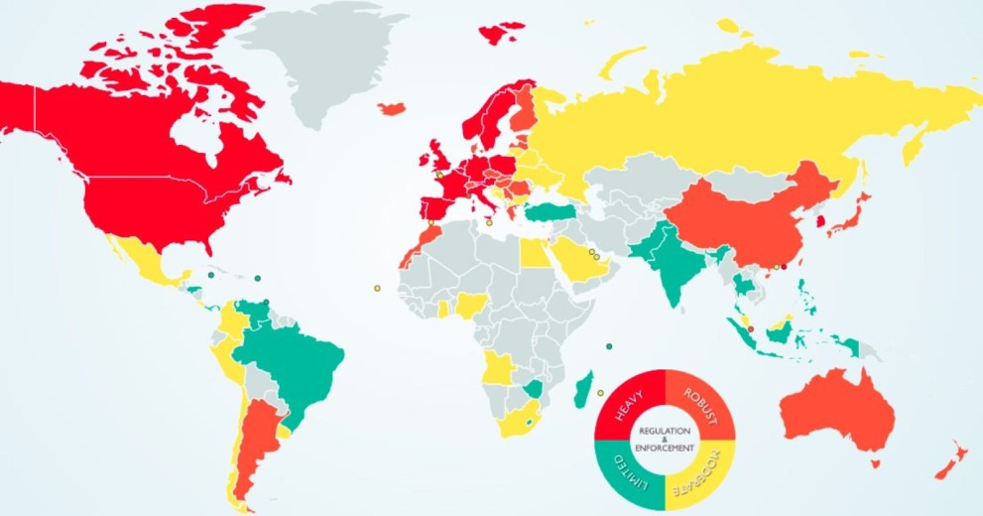
Why its important to AfRALO and African Internet Users ?
With reference to the Map above, the grey areas marks quite a few number of countries in Africa that has some or no proper privacy laws and may need to adopt some level of adoption. This calls for the African community to be alerted on the impact of the GDPR the fact that it will affect the African Economies especially the Economies of scale which is very important.
Action Items
Set up an AfRALO WG in collaboration with the ICANN Stakeholder Engagement Department and the GAC to discuss and draft a working plan to address the issues below:
African Region to build capacity and justify their policies in reference to how the GDPR affects the region
examine how the regulations will affect the African organizations and countries
raise awareness on the purpose of the GDPR to mitigate any risks that may result from non compliance;

Internet Governance activities and issues
Summary
Internet governance encompasses a range of issues, actors, stakeholders andissues discussed at manay technical or policy levels. Throughout the internet and networks, there exist problems that need solutions, and, more importantly, potential that can be unleashed by better governance. Annually AfRALO and its members participate in the IGF, recently in IGF 2017, AFRALO had a great presentations and a paneled discussion.
Why its important to AFRALO and African Internet Users?

With the goal to enhance regional engagement in Internet Governance, Internet governance activities and issues are important as they are encompassed by key players from all disciplines of Internet Governance and are a good a platform for Policy discussions, updates and engagement of the internet community.
Action Items
AFRALO represented and actively participating in the Internet Governance Forum at the different IG regional forums.

Capacity Building, Awareness and Outreach to Africa ( e.g Access of ICANN materials in African/Other languages other than English )
Summary
On 24 May 2016, ICANN celebrated the opening of the first African engagement office in Nairobi, Kenya. Over the past three years, the dedication and goodwill of ICANN community and staff members have been instrumental in implementing the Africa strategy. We hope to continue on this path, increasing our institutional engagement and outreach – key elements of ICANN's Africa strategy. There is need to increase awareness and outreach in Africa region despite the setting up of the Africa Engagement Office.
Why its important to AFRALO and African Internet Users ?
AFRALO and Africa Internet Users need more ICANN Materials to learn and understand the transition of the global domain and numbers industries.
There is also need to increase the awareness and outreach to various community and fora inorder to spread the gospel of the relevance of ICANN in the Internet industry.
Action Items
Coordinate with AFRALO Staff in Africa have ICANN materials in the region translated to more languages including Portuguese, Swahili etc
Distribute ICANN materials to ALSes for capacity building
Set up mechanisms to use local media (community radio, TV, social media on mobile phones) to increase awareness and reach out to communities with very limited internet access.

