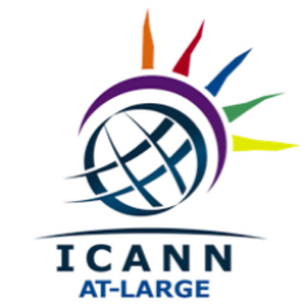

Draft AFRALO FY18 Outreach and Engagement Strategy

TABLE OF CONTENTS

Introduction 3
Aim of the Strategy 4
Strategy plan 5
Engagement Events targeted 6
Digital Engagement 7

Introduction

About AFRALO
AFRALO is the home of the individual Internet user community for the African region. It provides news, key resources and interactive information sharing tools for individuals and end-user groups in the African region who are interested in ICANN and in shaping the future of the Internet.

AFRALO aims to:
- Strengthen users’ participation in ICANN decision-making structures
- Help ensure that its members will actively encourage more direct participation by end users
- Build Internet policy making capacity in the region
- Reach out to Internet users on the issues in the scope of ICANN
- Represent users’ interests and defining public interest aspects of Internet governance with specific focus on the areas of privacy, transparency, and accountability
- Strengthen consumer protection in ICANN policies
- Identify social impacts of technical infrastructure design
- Take cultural diversity into account when formulating technical standards (e.g. IDN implementation)
AFRALO currently consist of 52 Allocated in 30 countries and territories.

To learn more about the ongoing work of AFRALO, you are welcome to check out its confluence wiki workspace: community.icann.org/display/AFRALOOpens a new window and its website at www.afralo.org

AFRALO Achievements
AFRALO has achieved tremendous success in outreach and engagement within the region especially with its participation in Africa Internet Summit and AFRINIC Meetings. We have achieved a high rise in the number of ALSes to current 53 African ALSes.

Aim of the Strategy
With the important increase in the number of ALSes, the strategy of FY18 will focus on Engagement of the end users and will aim at:
- Reaching out to African end users all over Africa to enhance engagement in the policy development processes and all other ICANN activities
- Promoting the ICANN multi-stakeholder model and its bottom-up decision making process
- Continuing the effort of recruitment of new members (At-Large Structures and/or individual members)

Strategy plan
To reach the aims of the strategy, AFRALO shall:
- Participate in events across Africa to:
  - Organize engagement sessions to present AFRALO, At-Large and ICANN to the event participants, explaining mission, constituencies and activities.
  - Make use of all breaks and social events to do the adequate outreach to bring African Internet organizations and individuals into ICANN Arena and make them interested to be involved in the processes
  - Make presentations about topics under discussion in ICANN to show how the African ICANN community participate effectively in the ICANN policy development
- Organize local events, in partnership with the local ALSes to enhance their engagement and broaden their radiance in their respective countries
- Continue to identify universities and academic institutions to organize fruitful discussions with students and teachers about Internet and ICANN to bring young people into ICANN through these Open Sessions

Engagement Events targeted
The engagement will be done at various forums within the Africa Region. The following non-exhaustive list identifies some targeted events:
- AFRINIC Meetings 2017 - AFRINIC 27
- Africa Internet Governance Forum 2017 – AfIGF 2017
- Africa Internet Summit 2018 – AIS’18

Digital Engagement
There is a need to ramp up engagement in Digital Platforms

