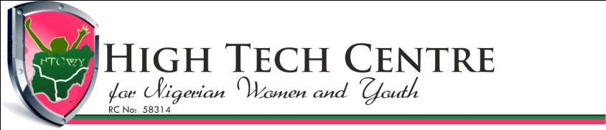
CALL FOR PARTICIPATION
Ladies and Women ICT Summit / Leaders Forum
About
The work life challenges of young women especially those aspiring for career in IT or Technology related fields also necessitate preparation and mentoring for female undergraduate and postgraduate students through our Ladies ICT Summit. Moreover, the roles of women and those who are leaders at various levels in national development cannot be over-emphasized, as they champion the enhancement of younger generation if put in the right perspective and direction of what is expected for sustainable growth. The effect and or, impact of the Internet and ICTs as a tool for the development of our society and communities are unquantifiable. Hence the need for us to continue to empower our women especially leaders who can take up challenges of sustainable development at rural communities for the overall achievement of not just actualizing the Millennium, but the new Sustainable Development Goals (M/SDGs) and the Change Agenda of our dear country.
The workshop, themed “REBRANDING NIGERIA WOMEN FOR TECH BUSINESSES” - Engaging Women and Leaders on Business and Entrepreneurship Opportunities in ICTs for Community and National Development, has special sessions and hands-on experience for the participants especially at the Ladies and Women Summits

Who to Attend: The workshop hosts Leaders, Females and women who include
      - Top Female CEOs & Functionaries at Federal and State Ministries,
      - Wives of National and State’s Assembly Hon. Members and Clerks,
      - Wives of Commissioners, Local Government Chairmen, Councilors and
      - Women Leaders of Political Parties the Supervisors
      - Female Officials or Directors of Relevant Ministries / Departments / Agencies across all States of the Federation and the FCT.
      - All women from ages 18years and above from the public, organized private sectors and all works of life
      - Undergraduate and Postgraduate Students of Nigeria Tertiary Institutions.
Event Details:
 | Event | Dates | Venue | Fees(N) | FREE Scholarships (100 women in all only)
1 | Ladies ICT Summit | 28th – 30th Sept, 2015 | Librarian Reg. Council, Maitama Abuja | 15,000.00 | For 30 Ladies in Tertiary Institutions
2 | Women ICT Summit | 29th – 30th Sept, 2015 | Sheraton Hotel , Abuja | 55,000.00 | For 50 Women across Nigeria
3 | Women Leaders Forum | 29th – 30th Sept, 2015 | Sheraton Hotel Abuja | 87,500.00 | For 20 Women in Leadership Positions

To Attend or Register: Register online at www.hightechwomen-ng.org or Send names to reachaoh@yahoo.co.uk or call 08034241874
All registration fees payments can be made to: Sterling Bank Plc, Account No: 0019052855 OR
Diamond Bank, Acct. No: 0034611000 Account Name: High Tech Centre for Nigerian Women and Youths

To Sponsor, Advertise in Events’ Brochure or Exhibit: Call 07033200204 or 08034241874

