Nominating Committee Report Card #6

June 2015
Date: 30 June, 2015

- Nominating Committee selects new leaders

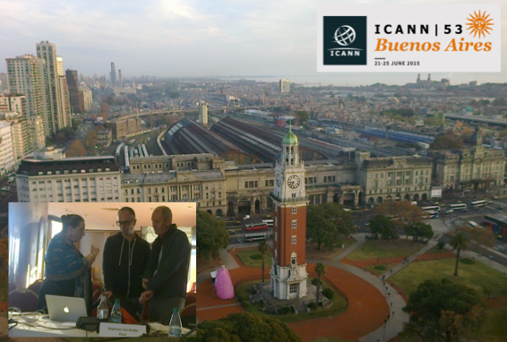

The 2015 Nominating Committee met in Buenos Aires at ICANN 53, interviewing a number of shortlisted Board candidates, and made its selections for vacant positions on the Board, on GNSO and ccNSO Councils, and on ALAC.

A total of 81 candidates had applied for the nine positions open in 2015. Some applied just for one, while others indicated their interest for multiple positions.

There were 51 candidates for the Board, 38 for the GNSO Council and 29 for the ccNSO Council. For the open positions for members from AFRALO, APRALO and LACRALO in ALAC, a total of 41 candidates applied: 16 from Africa, 9 from Asia/Australia/Pacific and 16 from Latin America/Caribbean.

2) Shortlisting and “deep diving”

Before meeting in Buenos Aires, the NomCom went through an intensive work period, assessing and shortlisting candidates on weekly calls and a straw poll platform on protected Wiki pages. NomCom members, working as pairs, were assigned to take a closer look at a 3-4 shortlisted candidates each pair. This process, known as “deep diving”, included phone interviews via Adigo with candidates for GNSO and ccNSO Councils, and for ALAC.

Fifteen 15 Board candidates, selected by NomCom on 21 April, were interviewed by phone and assessed by the Frankfurt office of Odgers Berndtson (OB), a leading recruitment firm that has performed this task for NomCom for several years. At its call on June 8, NomCom reviewed and discussed the scorecards prepared by OB on each of the 15, and selected a number of them to be interviewed in person by the full NomCom in Buenos Aires.

3) NomCom meetings in Buenos Aires

NomCom met on Sunday and Monday, 21-22 June, and on Wednesday and Thursday, 24-25 June, at the Plaza Hotel in Buenos Aires, and interviewed ten shortlisted candidates for the Board. Nine were physically present, one was interviewed on a Skype video/audio link.

The duration of each interview was 45 minutes. It was preceded by 15 minutes of discussion among committee members, with deep divers taking the lead. After each interview, the committee members discussed their impressions of the candidate for half an hour. The OB expert who had made telephone interviews with them, participated in the discussion.

The final selection meetings were held on Friday and Saturday, 26-27 June, in the Sheraton Hotel. Friday morning, Board candidates were discussed once more, and their pool gradually winnowed down by means of straw polls. In the afternoon, the same process took place regarding NomCom appointees (NCA) to the Councils of ccNSO and GNSO. On the latter, NomCom also determined, which one of the two NCA’s will go to the Contracted Parties House and which one to the Non-Contracted Parties House. Saturday morning, three NCA´s to ALAC were selected, one each from Africa, Latin America and Asia-Pacific.

At noon on Saturday, in the first and only official vote of its regular 2015 cycle, the NomCom endorsed the full slate of selectees to the Board, to the Councils of ccNSO and GNSO, and to the ALAC. The vote was unanimous.

In addition to the interview and selection meetings, the NomCom also met in Buenos Aires with the Board Governance Committee in the morning of Wednesday, June 24. Among other topics, the Bylaws provisions concerning regional diversity on the Board were discussed. Because one NomCom member (Fatimata Seye Sylla, ALAC-AF) was unable come to Buenos Aires due to visa problems, the NomCom repeated the plea, already made by many of its predecessors, that ICANN should insist on expedited visa policies for all essential meeting participants – such as NomCom members – as a precondition for accepting a country as a host of an ICANN meeting.

4) Next steps

The selections by NomCom will be announced in August/September, after a due diligence process, and the selectees will take up their seats at ICANN 54 in Dublin, 18 – 22 October, 2015.

Meanwhile, NomCom still has some tasks to accomplish. It has been asked to fill the NCA seat of NARALO at ALAC, which became vacant after its occupant was elected to one of the NARALO’s two regionally determined seats and resigned from the NCA position.

The 2015 NomCom will write its final report including recommendations, to be presented in Dublin.

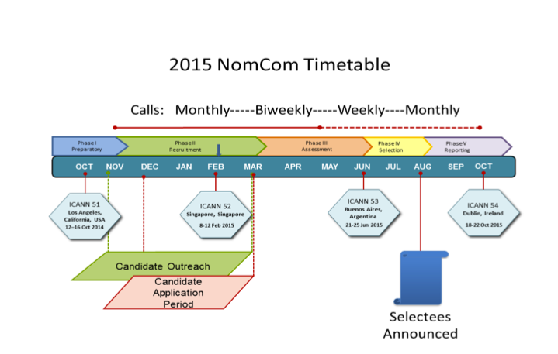

Appendix: 2015 NomCom essentials

Committee Leadership:
Chair (chosen by the Board): Stéphane Van Gelder; Associate Chair (chosen by Chair): Cheryl Langdon-Orr; Chair Elect (chosen by the Board to prepare for the Chairmanship of the 2016 NomCom): Ron Andruff

Committee:
Voting members: 5 ALAC; 1 ccNSO; 1 ASO; 1 IAB; 7 GNSO (RrSG, RySG, NCUC, ISPCP, IPC, CBUC [1 small / 1 large business rep]) Non-voting members: 1 SSAC, 1 RSSAC, 1 GAC
ICANN Staff support: Joette Youkhanna, Jia-Juh Kimoto

Sub-committees:
1. Conflict of interest (Chair: Cheryl Langdon-Orr)
2. Outreach and recruitment3 (Chair: Ron Andruff)
3. Transparency (Chair: Yrjö Länsipuro)
4. Wiki SOI revisions4 (Chair: Ron Andruff)
5. Alternates for unexpected vacancies (Chair: Cheryl Langdon-Orr)

Meetings (since the start of 2015 NomCom):

Kick-off face-to-face meeting in Los Angeles, 17-18 October, 2014

In attendance: Chair; Chair Elect; Associate Chair; 5 ALAC; 1 NCUC; 1 ISPCP; 1 ccNSO; 1 ASO; 0 IPC; 1 RrSG; 1 RySG; 1 SSAC; 1 RSSAC, 2 BC; 1 IAB for IETF. Apologies received from members unable to attend.
Teleconference 4 November, 2014

In attendance: Chair; Chair Elect; Associate Chair; 5 ALAC, 1 NCUC;1 ISPCP; 1 ccNSO; 1 ASO; 1 IPC; 0 RrSG; 1 RySG; 1 SSAC; 1 RSSAC, 2 BC; 0 IAB for IETF. Apologies received from members unable to attend.

Teleconference 2 December, 2014

In attendance: Chair; Chair Elect; Associate Chair; 5 ALAC, 1 NCUC;1 ISPCP; 1 ccNSO; 1 ASO; 1 IPC; 1 RrSG; 1 RySG; 1 SSAC; 0 RSSAC, 2 BC; 1 IAB for IETF. Apologies received from members unable to attend.

Teleconference 22 December, 2014

In attendance: Chair, Associate Chair, 5 ALAC, 1 NCUC, 1 ISPCP, 1ccNSO, 1 ASO, 0 IPC, 1 RrSG, 0 SSAC, 0 RSSAC, 2 BC, 1 IAB for IETF. Apologies received from members unable to attend.

Teleconference 28 January, 2015

In attendance: Chair, Chair Elect, Associate Chair, 4 ALAC, 1 NCUC, 0 ISPCP, 0 ccNSO, 1 IPC, 0 RrSG, 0 RySG, 0 SSAC, 0 RSSAC, 2 BC, 1 IAB for IETF. Apologies received from members unable to attend.

Face-to-face meeting at ICANN 52 in Singapore, 8 – 12 March, 2015

In attendance: Chair; Chair Elect; Associate Chair; 5 ALAC; 1 NCUC; 1 ISPCP; 1 ccNSO; 1 ASO; 1 IPC; 1 RrSG; 1 RySG; 1 SSAC; 1 RSSAC, 2 BC; 1 IAB for IETF.

Teleconference 1 April, 2015

In attendance: Chair, Chair Elect, Associate Chair, 5 ALAC, 1 NCUC, 1 ISPCP, 1 ccNSO, 0 IPC, 1 RrSG, 0 RySG, 1 SSAC, 0 RSSAC, 2 BC, 1 IAB for IETF. Apologies received from members unable to attend.

Teleconference 14 April, 2015

In attendance: Chair, Chair Elect, Associate Chair, 3 ALAC, 1 NCUC, 1 ISPCP, 0 ccNSO, 0 IPC, 1 RrSG, 0 RySG, 1 SSAC, 0 RSSAC, 2 BC, 0 IAB for IETF. Apologies received from members unable to attend.

Teleconference 21 April, 2015

In attendance: Chair, Chair Elect, Associate Chair, 5 ALAC, 1 NCUC, 1 ISPCP, 1 ccNSO, 1 ASO, 0 IPC, 1 RrSG, 0 RySG, 1 SSAC, 0 RSSAC, 1 BC, 1 IAB for IETF. Apologies received from members unable to attend.
Teleconference 28 April, 2015

In attendance: Chair, Associate Chair, 4 ALAC, 1 NCUC, 1 ISPCP, 1 ccNSO, 1 ASO,
1 IPC, 1 RrSG, 0 RySG, 1 SSAC, 0 RSSAC, 2 BC, 1 IAB for IETF. Apologies received from members unable to attend.

Teleconference 5 May, 2015

In attendance: Chair Elect, Associate Chair, 5 ALAC, 1 NCUC, 1 ISPCP, 1 ccNSO, 0 ASO,
0 IPC, 1 RrSG, 0 RySG, 1 SSAC, 0 RSSAC, 1 BC, 1 IAB for IETF. Apologies received from members unable to attend.

Teleconference 12 May, 2015

In attendance: Chair, Associate Chair, 4 ALAC, 1 NCUC, 1 ISPCP, 1 ccNSO, 0 ASO,
1 IPC, 0 RrSG, 0 RySG, 1 SSAC, 0 RSSAC, 2 BC, 1 IAB for IETF. Apologies received from members unable to attend.

Teleconference 8 June, 2015

In attendance: Chair, Chair Elect, Associate Chair, 5 ALAC, 1 NCUC, 1 ISPCP, 1 ccNSO, 1 ASO, 1 IPC, 1 RrSG, 0 RySG, 1 SSAC, 1 RSSAC, 2 BC, 1 IAB for IETF.

Face-to-face meeting at ICANN 53 and after in Buenos Aires, 21- 27 June, 2015

In attendance: Chair, Chair Elect, Associate Chair, 5 ALAC, 1 NCUC, 1 ISPCP, 1 ccNSO, 1 ASO, 1 IPC, 1 RrSG, 0 RySG, 1 SSAC, 1 RSSAC, 1 BC, 1 IAB for IETF

