Microsoft/USTTI Cybersecurity Policy Training
Getting to the Microsoft Office – Istanbul, Turkey

Address:
Microsoft Bilgisayar Yazılım
Bellevue Residences, Levent Mahallesi
Aydın Sokak No:7, Levent 34340

By Private Car or Taxi
(from IGF Village at the Lütfi Kırdar Conference Center)

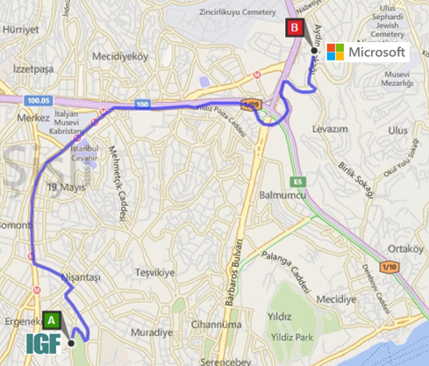
Journey Time: Approximately 20 minutes (with light traffic)

Taxi Fare: Approximately 15-20 Turkish Liras

By Metro (Subway)

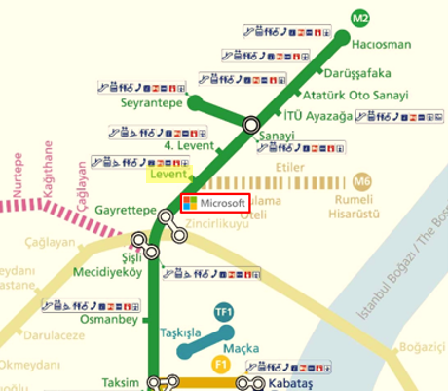
Nearest Stop:
Levent Metro Station, on Line 2 (M2)

Ticket Price:
Single-Use Metro Token Costs Approximately 4 Turkish Liras

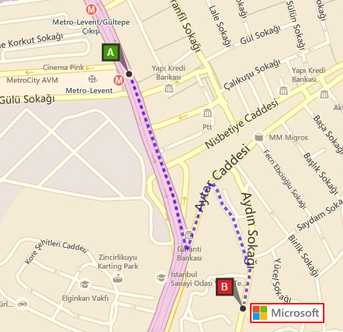
Walk to the Office:
Approximately 12 minutes

Route:
As shown on the map
- Walk down along Büyükdere Caddesi towards Garanti Bank HQ

- Next, take a left on Aytar Caddesi

- Then, take a right on Park Sokak until you reach Aydin Sokak

- You should now see the Microsoft Office next to the Bellevue Residence building

