2015 Nominating Committee Report Card #2
November-December 2014
Date: 11 December 2014

- Application period opens 8 December

The application period for nine ICANN leadership positions to be filled in 2015 was opened on 8 December, 2014. It will run until 15 March, 2015.

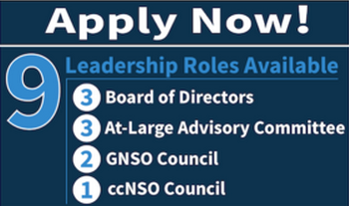

The open positions are:

- Three members of the ICANN Board of Directors
- Three At-Large Advisory Committee (ALAC) representatives (one each from the Africa, Asia/Australia/Pacific Islands and Latin America/Caribbean Islands regions)
- Two members of the Council of the Generic Names Supporting Organization (GNSO)
- One member of the Council of the Country Code Names Supporting Organization (ccNSO)

Before the start of the application period, the online application form had been updated on the basis of the experience of the previous year by the Wiki Sub-Committee.
In order to maintain the confidentiality of the application process, it is conducted within a restricted ICANN wiki space. To start the process, the candidate first requests an application form.

2) Outreach

All NomCom members are now engaged in outreach activities within their own networks and at various events where they participate. As an example, an AFRALO Task Force is working for increased African representation in the ICANN leadership. They did outreach in connection with the AFRINIC-21 Meeting in Mauritius and the XV Summit of the Francophonie in Dakar at the end of November.

The ICANN 52 meeting (Singapore, 8-12 February 2015) will be used by all NomCom members for outreach among the entire community.

The Outreach Sub-Committee is working with the staff on a calendar of events in various regions where outreach could be made. The template will be available to subsequent NomComs as well.

3) External recruitment assistance

Continuing the practice of the 2011 and 2013-2014 NomComs, the 2015 NomCom has decided to use the assistance of Odgers Berndtson (OB), an international executive search firm in the recruitment of candidates for the Board positions. On 14 November, the NomCom Chair met with OB executives in Brussels to explain the approach of the 2015 NomCom and the criteria for Board positions. NomCom is also going to use the services of a different unit of OB (based in Frankfurt) in assessing candidates for the Board.

4) Community input in the NomCom process

SO’s and AC’s have been asked to update the skill sets and criteria that in their view should inform the selections by the NomCom. They will be posted on the NomCom web site.

5) Enhancing transparency

The 2015 NomCom is working to enhance further the transparency of its work process, while keeping the personal data of the candidates absolutely confidential. The Transparency Sub-Committee is engaged in improving the means already used 2013-2014 (report card, open meetings, comprehensive final report) and developing new ones, e.g. using social media more effectively.

6) Next steps

The next teleconference of the NomCom will be in January 2015 in preparation for the face-to-face meetings at ICANN 52.

Continuing the practice of its two predecessors, 2015 NomCom will hold in Singapore an open business meeting, which is an opportunity for community members to give their views to the NomCom and to find about its work. At its internal sessions, NomCom members will be trained in interview techniques and familiarized with Wiki based tools for candidate assessment.

After the applications deadline, the NomCom will start assessing the candidates, with an accelerating schedule of teleconferences in April-June. Shortlisted Board candidates will be invited to ICANN 53 (Buenos Aires, June 21-25, 2015) for interviews. NomCom will hold its final selection meeting immediately after ICANN 53.

Selections are announced in August/September, and selectees will take up their positions after ICANN’s Annual General Meeting (Dublin, October 18-22 2015)

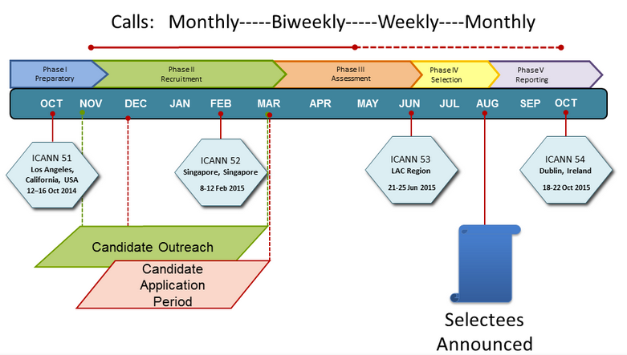
Appendix: 2015 NomCom essentials

Committee Leadership:
Chair (chosen by the Board): Stéphane Van Gelder Associate Chair (chosen by Chair): Cheryl Langdon-Orr Chair Elect (chosen by the Board to prepare for the Chairmanship of the 2016 NomCom): Ron Andruff
Committee:
Voting members: 5 ALAC; 1 ccNSO; 1 ASO; 1 IAB; 7 GNSO (RrSG, RySG, NCUC, ISPCP, IPC, CBUC [1 small / 1 large business rep])
Non-voting members: 1 SSAC, 1 RSSAC, 1 GAC1 ICANN Staff support: Joette Youkhanna, Jia-Juh Kimoto
ICANN Staff support: Joette Youkhanna, Jia-Juh Kimoto

Sub-committees:

- Conflict of interest (Chair: Cheryl Langdon-Orr)
- Outreach and recruitment (Chair: Ron Andruff)
- Transparency (Chair: Yrjö Länsipuro)
- Wiki SOI revisions (Chair: Ron Andruff)
- Alternates for unexpected vacancies (Chair: Cheryl Langdon-Orr)

Meetings:

Kick-off face-to-face meeting in Los Angeles, 17-18 October, 2014

In attendance: Chair; Chair Elect; Associate Chair; 5 ALAC; 1 NCUC; 1 ISPCP; 1 ccNSO; 1 ASO; 0 IPC; 1 RrSG; 1 RySG; 1 SSAC; 1 RSSAC, 2 BC; 1 IAB for IETF. Apologies received from members unable to attend.

Teleconference 4 November, 2014

In attendance: Chair; Chair Elect; Associate Chair; 5 ALAC, 1 NCUC;1 ISPCP; 1 ccNSO; 1 ASO; 1 IPC; 0 RrSG; 1 RySG; 1 SSAC; 1 RSSAC, 2 BC; 0 IAB for IETF. Apologies received from members unable to attend.

Teleconference 2 December, 2014

In attendance: Chair; Chair Elect; Associate Chair; 5 ALAC, 1 NCUC;1 ISPCP; 1 ccNSO; 1 ASO; 1 IPC; 1 RrSG; 1 RySG; 1 SSAC; 0 RSSAC, 2 BC; 1 IAB for IETF. Apologies received from members unable to attend.

https://www.icann.org/resources/pages/2015-2014-11-14-en
https://forms.icann.org/en/groups/nomcom/apply
https://community.icann.org/display/AFRALO/AFRALO+Task+force%3A+Outreach+for+more+African+representation+in+ICANN+leadership+positions+2014-11-18
http://www.odgersberndtson.com/en/

