2015 NomCom
Report Card #1

October 2014

Issue date: 7 November 2014

NomCom 2015 essentials

Committee Leadership:
Chair (chosen by the Board): Stéphane Van Gelder
Associate Chair (chosen by Chair): Cheryl Langdon-Orr
Chair Elect (chosen by the Board to prepare for the Chairmanship of the 2016 NomCom): Ron Andruff

Committee:
Voting members: 5 ALAC; 1 ccNSO; 1 ASO; 1 IAB; 7 GNSO (RrSG, RySG, NCUC, ISPCP, IPC, CBUC [1 small / 1 large business rep])

Non-voting members: 1 SSAC, 1 RSSAC, 1 GAC

ICANN Staff support: Joette Youkhanna, Jia-Juh Kimoto

Current work

Joint meetings with 2014 NomCom at ICANN 51 in Los Angeles, 15-16 October, 2014

The 2014 and 2015 NomComs held a joint public meeting on Thursday, 16 October, during ICANN 51 in Los Angeles for the purpose of presenting the final report and recommendations of the 2014 NomCom and of introducing the 2015 NomCom to the community.

During ICANN 52, the Leadership Teams (LT) of both 2014 and 2015 NomComs met with NCUC, RSSAC, CSG, ALAC, SSAC and RrSG. LT’s and members of both 2014 and 2015 also participated actively in the public meeting on BWG-Nom Com Review Report.

2015 NomCom Kick-off meeting in Los Angeles, 17-18 October, 2014

In attendance: Chair; Chair Elect; Associate Chair; 5 ALAC; 1 NCUC; 1 ISPCP; 1 ccNSO; 1 ASO; 0 IPC; 1 RrSG; 1 RySG; 1 SSAC; 1 RSSAC, 2 BC; 1 IAB for IETF. Apologies received from members unable to attend.

Immediately following the ICANN 51 meeting, the 2015 NomCom met for two full days of kick-off sessions, on Friday and Saturday, 17-18 October.

The Committee met with the Board Governance Committee; Board Chairman; ICANN CEO, and ICANN General Counsel for briefings and exchange of ideas and information to frame its work.

The 2015 NomCom reviewed its task, that is: to select three Board members, three ALAC members (one from Africa, one from Asia/Australia/Pacific Islands and one from Latin America/Caribbean), two GNSO Council members (voting) and one ccNSO Council member, and discussed their qualifications and skill sets in light of the Bylaws of ICANN and input from the constituencies concerned. Outgoing positions, including regions and term limits for each, will be published on the 2015 NomCom website.

The Committee discussed its timetable and the various phases of its work. The application period will run from December 2014 to March 2015 (exact dates to be determined). It was noted that an early application deadline gives the Committee more time for the assessment of candidates.

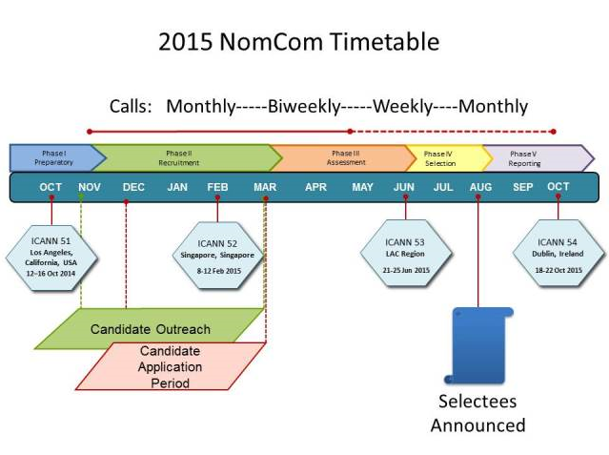

An overview of NomCom Code of Conduct, as well as of its guidelines and operating procedures, inherited from earlier NomComs, was made in light of the recommendations by the 2014 NomCom.

The Committee decided to continue and further develop the practices of its two predecessors, of opening the NomCom process for the community, within limits set by the confidentially requirements about candidates. Thus, monthly report cards will continue to be issued to the community, and the practice of having public NomCom working meetings at the three annual ICANN public meetings will be continued and further developed. Following the practice of the 2014 NomCom, peer (“360 degree”) reviews will be made and published.

A “Whistle-blower” e-mail address will be created for NomCom members to report possible misconduct. In order to facilitate any such reports made on the Leadership Team, such emails will first be sent to ICANN support staff. If the report does not reference the NomCom Chair, staff will forward it to the Chair for processing. If the report does reference the NomCom Chair, staff will forward it to the Chair Elect for processing.

The Committee also discussed its outreach activities, candidate information management and candidate evaluation and selection processes. Use of external contractors to help the Committee in the recruitment and evaluation phases of its work were discussed in light of past experiences.

Following sub-committees were set up:

- Conflict of interest (Chair: Cheryl Langdon-Orr)
- Outreach and recruitment (Chair: Ron Andruff)
- Transparency (Chair: Yrjö Länsipuro)
- Wiki SOI revisions (Chair: Ron Andruff)

The first teleconference of the 2015 NomCom will be held on 4 November.

Since 2007, GAC has not appointed a representative to the NomCom
According to the ICANN Bylaws (Article VII.7), the Nominating Committee shall adopt such operating procedures as it deems necessary, which shall be published on the Website

