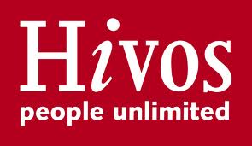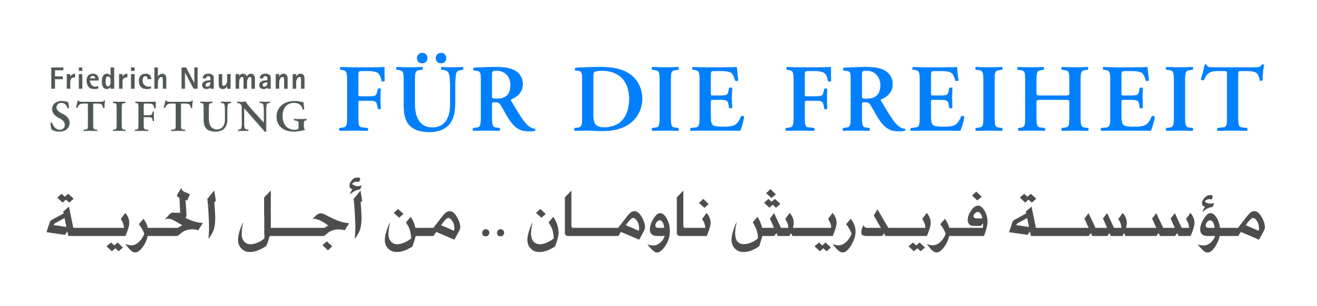

Call for participation

Training Program on Internet Governance and policy in the Middle East and North Africa
16-19 March 2013

The quest for an open and a free of government control Internet in the Arab countries has brought the need to engage more Internet users from the region in the global discussion about Internet Governance and the policies specific to the Internet environment.
While the concept of Internet Governance is not widespread in the Arab region and it sounds very technical and complicated, it is in fact related to the overall process of Internet management, its security, stability and development. There is lack of understanding and knowledge of most Arab Internet users about the regional and global policy environment related to the Internet which impedes their full participation and integration in the discussion as a main stakeholder. Therefore, engaging Arab Internet users in the regional and global debate about Internet Governance requires building knowledge in the subject matter.

The Humanist Institute for Co-operation with Developing Countries (Hivos) www.hivos.org is organizing a training program on Internet Governance and policy in the Arab region between March 16th and 19th 2013 in Tunis in partnership with Friedrich Naumann Foundation for Freedom www.freiheit.org
The training will bring participants together from various disciplines to learn about Internet Governance process and to exchange ideas about Internet issues specific to the Arab region; it will cover three dimension content which combines advocacy, policy and technology.
Candidates interested in advancing their knowledge about Internet Policy and would like to be part of the regional and global discussion about topics related to the management of the Internet, institutions involved and processes, Internet freedom, cyber security and cyber crime, privacy online, Internet and human rights and freedom of expression online are encouraged to apply for this custom made training targeting participants from the Arab region and featuring international and Arab region experts in Internet Governance and Internet public policy.

Selection Criteria
If you are a blogger, journalist, human rights activist, scholar, student with a legal background, political science or International relations, public sector employees at the national regulator or at the ministry of communication and technology, member of the private sector representing a company operating in the Internet industry, fluent in English or French, have basic knowledge about Internet issues related to the Arab region, and willing to take part physically in a 4 day extensive training which will offer you the possibility to access an international network of group of experts in the subject of Internet Governance and policy. Please send your CV including a photo, a short biography (300 words) and a sample of writing about Internet issues related to your country of origin and why you think you should be selected to participate in the training. Application is open until Sunday, 3rd February 2013 at midnight CET and to be sent to: aig@hivos.nl
Only complete applications will be considered. Selected candidates will be contacted by Friday, 15th February 2013.
Note: While most of the training material and sessions will be conducted in English, participants are encouraged to initiate discussions in Arabic.

About The Humanist Institute for Co-operation with Developing Countries (Hivos)
Hivos is an international development organization guided by humanist values. Together with local civil society organizations in developing countries, Hivos wants to contribute to a free, fair and sustainable world. A world in which all citizens – both women and men – have equal access to opportunities and resources for development and can participate actively and equally in decision-making processes that determine their lives, their society and their future.
About Friedrich Naumann Foundation for Freedom
The Friedrich Naumann Foundation for Freedom is the foundation for liberal politics in the Federal Republic of Germany. It aims to promote the goal of making the principle of freedom valid for the dignity of all people and in all areas of society, both in Germany and abroad. With the safeguarding and the development of its statutory projects (civic education and dialogue, sponsorship of the talented, research and political consultation, archive-work), the Friedrich Naumann Foundation wants to contribute to shaping the future.

